NO | TOPIC | SUBTOPIC
1 | SAFETY REGULATIONS | - healthy and safety  - personal hygiene  - first aid procedures  - fires
2 | HAND TOOLS | - classification of hand tools
- classification of hand tools
- hand tools
- care and maintenance of cutting tools
3 | MACHINE TOOLS | - description of machine tools  - classification of machine tools  - safety
4 | DIESEL AND PETROL ENGINES | - diesel and petrol engines  - fuel systems  - engine construction
5 | WATER PUMPS | - types  - working principles  - maintenance
WORKSHOP TECHNOLOGY 1

TOPIC ONE
SAFETY REGULATIONS
Workshop safety rules
Safety is a term used to denote on behaviour to contral our actions and working conditions when carrying out our duties that we do not expose ourselves to accidents.
Dress
- Always wear tight fitting clothes
- Always use heavy protective foot wear
- Have long hairs and nails cut always while in a workshop
- Always use protective googles where required.
Behaviour
- Always avoid carelessness
- Avoid overcrowding while in a work place
- Always avoid playing while in a work place
- Avoid sitting idle in a workshop
Fire fighting equipment
- Be Knowledgeable for use of equipment when in a work place
- Fire fighting equipment should be fitted in a suitable position for quick location
- Ensure firefighting equipment is always refilled
Ladder work
- Hard and tough materials to be used for ladders
- They should be placed at suitable position so that it does not slip and overturn.
- Proper anchorage both at top and bottom
- Never strain or over rich something when on a ladder
Untidiness, harmful materials and carrying of materials
- Keep working areas tidy and dry
- Leave no pieces, sticking nails or metals on floors
- Keep all flammable materials in a closed container.
- Avoid inhaling poisonous gases.
First aid kit
- Quick location and access to the needy person
- Always ensure the replacement of contents when finished
- Report injuries however small.
Employer’s responsibilities

Provide and maintain machinery, equipment and other plant, and systems of work that are safe and without risk to health. (‘Systems of work’ means the way in which the work is organized and includes layout of the workplace, the order in which jobs are carried out or special precautions to be taken before carrying out certain hazardous tasks.)

Ensure ways in which particular articles and substances (e.g. machinery and chemicals) are used, handled, stored and transported are safe and without risk to health.

Provide information, instruction, training and supervision necessary to ensure health and safety at work. Information means the background knowledge needed to put the instruction and training into context. Instruction is when someone shows others how to do something by practical demonstration. Training means having employees practice a task to improve their performance. Supervision is needed to oversee and guide in all matters related to the task.

Ensure any place under their control and where their employees work is kept in a safe condition and does not pose a risk to health. This includes ways into and out of the workplace.

Ensure the health and safety of their employees’ working environment (e.g. heating, lighting, ventilation, etc.). They must also provide adequate arrangements for the welfare at work of their employees (the term ‘welfare at work’ covers facilities such as seating, washing, toilets, etc.). a safe system of work;

.Employees’ responsibilities
To take reasonable care for their own health and safety and that of others who may be affected by what they do or don’t do. This duty implies not only avoiding silly or reckless behavior but also understanding hazards and complying with safety rules and procedures. This means that you correctly use all work items provided by your employer in accordance with the training and instruction you received to enable you to use them safely.

To co-operate with their employer on health and safety. This duty means that you should inform, without delay, of any work situation which might be dangerous and notify any shortcomings in health and safety arrangements so that remedial action may be taken.

Regulations for health and safety at work
- Management of Health and Safety at Work Regulations.
- Provision and Use of Work Equipment Regulations.
- Workplace (Health, Safety and Welfare) Regulations.
- Personal Protective Equipment at Work Regulations.
- Health and Safety (Display Screen Equipment) Regulations.
- Manual Handling Operations Regulations

Electrical hazards
Electricity cannot be seen or heard but it can easily kill, even if it is not fatal serious disablement can be resulted through shocks and burns.
Faulty wiring or faulty equipment’s are the major causes of electrical disorders.
Hazards from electrical equipment’s includes
- Electric shock
Body response in a number of ways to electric current flowing through it
- Electric burn
Due to heating effect caused by electric current flowing through the body tissue.

- Fire
Caused by electricity in a number of ways including: overheating of cables, leakage of current, poor or inadequate insulation, sparks of electrical equipment’s etc.
Electrical precautions
These are there measures to be taken to prevent injuries caused by electrical appliances and equipment’s.
Double insulation Cover live conductors with two discrete layers of insulation.
Earthling Through earthling faults on electrical equipment’s can be detached and electrical supply to be cut off automatically. Automatic cut off is performed by fuses or automatic circuit breakers.

Electric shocks and treatment
What to do in case of an electric shock
- Shout for help-if the causality is still in contact with electric current s3witch off or remove the plug.
- If current cannot be switched off take special care to stand on a dry non conducting surface and pull or push the victim using a non-conducting material. I.e. don’t touch the casualty with your bare hand because you will complete the circuit and also receive a shock.
- Once free, if he/ she is breathing put him/her in recovery position and get the causality to n the hospital and if the causality I s not breathing give him or her mouth to mouth resuscitation before taking him/ her to hospital.

FIRES
It is a phenomenon in which combustible materials especially by organic materials containing carbon reacts chemically with oxygen in the air to produce heat.
Reasons for fire starting
- Misuse or faulty of electrical equipment or tools- e.g. use of incorrect plugs, overloading, and use of wiring damaged cables etc.
- Cigarettes and matches- smoking in unauthorized places, throwing away cigarettes or matches carelessly.
- Rubbish burning-casual burning of wastes and rubbish.
- Mechanical heat, sparks-sparks produced by grinding and cutting operations.
Reasons for spread of fire
- Delayed discovery
- Combustible lining of roof, ceiling and walls.
- Rapid burning of dust deposit.
- Lack of fire separating walls between production and storage areas.
Fire prevention
- The maximum number of workers and officers should be trained with firefighting systems and equipment’s.
- Keep all flammable liquids in closed containers or in safe cylinders.
- Effective fire warning signals.
- All doors should be opened towards outside the workroom as means of escape in case of fire.
- The doors and windows to be used as exit in case of fire should be easily located.
These should be marked with red letters of adequate size. One should provide ventilation to prevent any accumulation of vapors.
- Always provide suitable and adequate means of fire extinguishment.
- Every operator should be familiar with the location of fire extinguishers and their use (operation).
- Proper clearance should always be there in between the heating device and any combustible material.
- Electrical wiring should be proper.
- Always prohibit smoking, open flames and sparks near the flammable materials.
- A free passageways and easily open-able windows should be always provided.
- . Provide always suitable means for the safe storage and handling of all fuel used.
- Use of flammable liquids should be minimized
- Safe disposal for the flammable liquid wastes must be provided.
- No one is permitted to accumulate fuels or other combustibles near the source of open fire or spark

Types of fire

There are three major types of fires which are given as under.
- Type 1/class A Fires occurring due burning of ordinary combustible materials such as wood, cloth and paper. Pouring water is the most effective way for extinguishing this kind of fire.
- Type 2/class B Fires occurring due burning of flammable liquids such as oils, petrol, grease and fat. For extinguishing, blanket or smother this kind of fire, thus excluding oxygen, water must never be used.
- Type 3/class C Fires in this category involve live electrical equipment. The extinguishing agent must be non-conducting of electricity and water must not be used for extinguishing this kind of fire.

Other types of fire includes
Class D- fire occurs with combustible metals, for example magnesium
Class K

For fire to occur it requires oxygen,fuel and heat. The fire triangle indicates all these requirements.
Oxygen (to sustain combustion)
Fuel (inform of any combustible material)

FIRE TRIANGLE

Heat (enough to raise the fuel to its ignition temperature)

If any element in the fire triangle is removed the fire will be extinguished. Fire will also not start if one element is missing.
This leads to different fire extinguishers commonly available for different types of fire.

Fire extinguishers
Fire extinguishers are available in different types with each one having specific fire classes that they are suitable for use on. Fire extinguishers should have a red body and an agent specific colour band covering between 5-10% of the surface relating to the extinguisher's contents.
- WATER
- Water fire extinguishers have a class A rating and are suitable for fighting fires involving solid combustibles such as wood, paper and textiles.
- Electrical equipment should be avoided when using a water extinguisher (unless water with additive are used). as water is a conductor.
- FOAM
- Foam fire extinguishers are highly effective on class A and class B fires (the foam agent helps to prevent re-ignition).
- Some foam extinguishers have been dielectrically tested to 35000 Volt (35kV) and can be used on or near electrical appliances.
- CARBON DIOXIDE (CO2)
- CO2 fire extinguishers were originally designed for use on flammable liquid fires and therefore it is suitable for class Band C
- They are ideal for electrical fires, as CO2 is not a conductor and they do not leave behind any harmful residue.

- DRY POWDER
- These extinguishers filled with dry powder may be of the gas pressure or stored air pressure type.
- Dry powder fire extinguishers are extremely versatile and can be used on class B, class C and class D .
- They are available in a range of sizes from 1 - 9kg and are ideal for application in environments containing mixed fire risks. However, there is a risk of inhalation when using powder extinguishers indoors.
- Powder fire extinguishers are therefore not recommended for use within small rooms, homes and offices.

TOPIC TWO
HAND TOOLS
These are tools which are powered by the use of hands.

Classes of hand tools
- Cutting tools
- Measuring tools
- Forming tools
- Fastening tools
- Holding tools

Cutting tools
They include;
- Files
- chisels
- Punches
- Reamers
- Taps
- saws

Holding tools
These are tools that firmly hold work pieces in the workshop.
They include;
- vise
- pliers
- clamps

Forming tools
They include;
- mallets
- hammers
- files

Measuring tools
They include;
- calipers
- tapes
- rules

FILES
They are often used to put the finishing touches on a machined work piece, either to remove burrs or sharp edges or as a final fitting operation. Intricate parts or shapes are often produced entirely by skilled workers using files.

There are a number of different types of files in common use, and each type may range in length from3 to 18 inches.

Grades
Files are graded according to the degree of fineness and whether they have single- or double-cut teeth. The difference is apparent when you compare the files in Single-cut files have rows of teeth cut parallel teach other. These teeth are set at an angle of about 65 degrees with the centerline.Youwill use single-cut files for sharpening tools, finish filing, and draw filing. They are also the best tools for smoothing the edges of sheet metal. Files with crisscrossed rows of teeth are double-cut files. The double cut forms teeth that are diamond-shaped and fast cutting. You will use double-cut files for quick removal of metal and for rough work. Files are also graded according to the spacing and size of their teeth, or their coarseness and fineness. Some of these grades are pictured in view B. In addition to the three grades shown, you may use some DEAD
SMOOTH files, which have very fine teeth, and some ROUGH files, with very coarse teeth. The fineness or coarseness of file teeth is also influenced by the length of the file. (The length of a file is the distance from the tip to the heel, and does not include the tang view C.)When you have a chance, compare the actual size of the teeth of a 6-inch, single-cut smooth file and a 12-inch, single-cut smooth file; you will notice the 6-inch file has more teeth per inch than the 12-inch file.

Shapes
Files come in different shapes. Therefore, in selecting a file for a job, consider the shape of the finished work. Some of the cross-sectional shapes includes
- TRIANGULAR files are tapered on all three sides. They are used to file acute internal angles and to clear out square corners. Special triangular files are used to file saw teeth.
- MILL files are tapered in both width and thickness. One edge has no teeth and is known as a SAFE EDGE. Mill files are used for smoothing lathe work, draw filing, and other fine, precision work. Mill files are always single-cut.
- FLAT files are general-purpose files and may be either single- or double-cut. They are tapered in width and thickness. HARD files, not shown, are some thicker than flat files. They taper slightly in thickness, but their edges are parallel. The flat or hard files most often used are the double-cut for rough work and the single-cut smooth file for finish work.
- SQUARE files are tapered on all four sides and are used to enlarge rectangular-shaped holes and slots.
- ROUND files serve the same purpose for round openings. Small round files are often called "rattail"files.
- HALF ROUND file is a general-purpose tool. The rounded side is used for curved surfaces, and the flat face on flat surfaces. When you file an inside curve, use a round or half-round file whose curve most nearly matches the curve of the work. Kits of small files, often called "Swiss pattern" or “jewelers'" files, are used to fit parts of delicate mechanisms and for filing work on instruments. Handle these small files carefully because they break easily.

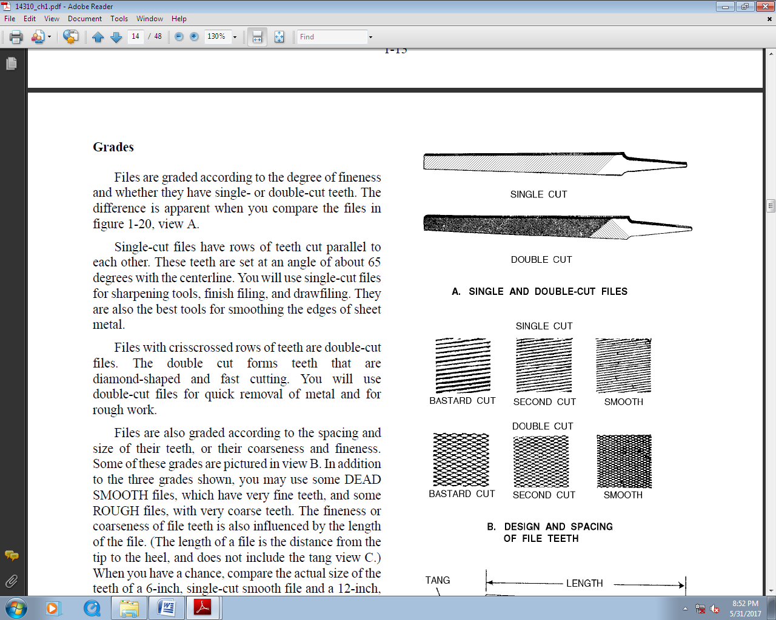

Filing Operations
Using a file is an operation that is nearly indispensable when working with metal. You may be cross filing, draw filing, using a file card, or even polishing metal. Let's examine these operations. When you have finished using a file, it may be necessary to use an abrasive cloth or paper to finish the product. Whether this is necessary depends on how fine a finish you want on the work.

CROSSFILING
This means that the file is being moved across the surface of the work in approximately a crosswise direction. For best results, keep your feet spread apart to steady yourself as you file with slow, full-length, steady strokes. The file cuts as you push it—ease up on the return stroke to keep from dulling the teeth. Keep your file clean. View B shows the alternate positions of the file when an exceptionally flat surface is required. Using either position first, file across the entire length of the stock. Then, using the other position, file across the entire length of the stock again. Because the teeth of the file pass over the surface of the stock from two directions, the high spots and low spots will readily be visible after filing in both positions. Continue filing first in one position or direction and then the other until the surface has been filed flat. Test the flatness with a straightedge or with Prussian blue and a surface plate.

DRAWFILING.
Draw filing produces a finer surface finish and usually a flatter surface than cross filing. Small parts, as shown in view C, are best held in a vise. Hold the file as shown in the figure; notice that the arrow indicates that the cutting stroke is away from you when the handle of the file is held in the right hand. If the handle is held in the left hand, the cutting stroke will be toward you. Lift the file away from the surface of the work on the return stroke. When draw filing will no longer improve the surface texture, wrap a piece of abrasive cloth around the file and polish the surface.

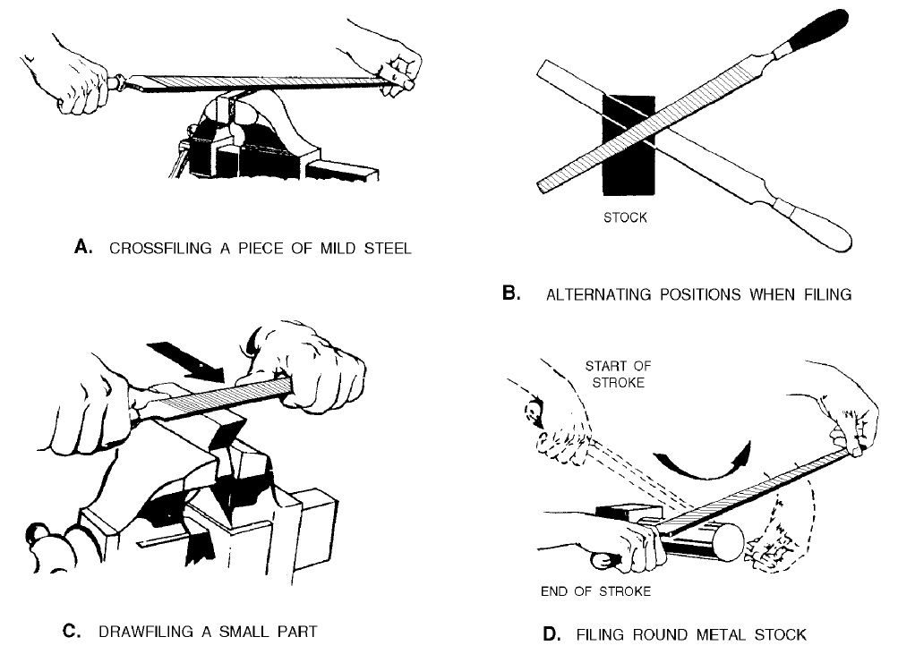

USE OF FILE CARD.
As you file, the teeth of the file may "clog up" with some of the metal filings and scratch your work. This condition is known as PINNING. You can prevent pinning by keeping the file teeth clean. Rubbing chalk between the teeth will help prevent pinning, too, but the best method is to clean the file frequently with a FILE CARD or brush. A file card has fine wire bristles. Brush with a pulling motion, holding the card parallel to the rows of teeth. Always keep the file clean, whether you're filing mild steel or other metals. Use chalk liberally when filing nonferrous metals.
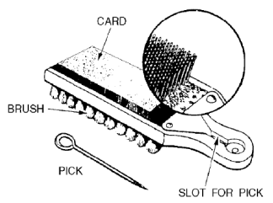

Care of Files
A new file should be broken in carefully by using it first on brass, bronze, or smooth cast iron. Just a few of the teeth will cut at first, so use a light pressure to prevent tooth breakage. Do not break in a new file by using it first on a narrow surface. Protect the file teeth by hanging your files in a rack when they are not in use or by placing them in drawers with wooden partitions. Your files should not be allowed to rust—keep them away from water and moisture. Avoid getting the files oily. Oil causes a file to slide across the work and prevents fast, clean cutting. Files that you keep in your toolbox should be wrapped in paper or cloth to protect their teeth and prevent damage to other tools. Never use a file for prying or pounding. The tang is soft and bends easily. The body is hard and extremely brittle. Even a slight bend or a fall to the deck may cause a file to snap in two. Do not strike a file against the bench or vise to clean it—use a file card.

Safety
Never use a file unless it is equipped with a tight-fitting handle. If you use a file without the handle and it bumps something or jams to a sudden stop, the tang may be driven into your hand. To put a handle on a file tang, drill a hole in the handle, slightly smaller than the tang. Insert the tang end, and then tap the end of the handle to seat it firmly. Make sure you get the handle on straight.

HACKSAW
Hacksaws are used to cut metal that is too heavy for snips or bolt cutters. Thus, metal bar stock can be cut readily with hacksaws

The hacksaw consists of three parts: the frame, the handle, and the saw blade .Frames are either the solid or adjustable type. The solid frame can be used with only one length of saw blade. The adjustable frame can be used with hacksaw blades from 8 to 12 in. in length. The blade can be mounted to cut in line with the frame or at a right angle to the frame. By turning the blade at right angles to the frame, you can continue a cut that is deeper than the capacity of the frame. If the blade is left in line with the frame, the frame will eventually hit the work piece and limit the depth of cut. Most hacksaw blades are made from high-speed steel and in standard lengths of 8, 10, and 12 in. Blade length is the distance between the centers of the holes at each end.

The SET in a saw refers to how much the teeth are pushed out in opposite directions from the sides of the blade. The four different kinds of set are the ALTERNATE set, DOUBLE ALTERNATE set, RAKER set, and WAVE set.
The teeth in the alternate set are staggered, one to the left and one to the right throughout the length of the blade. On the double alternate set blade, two adjoining teeth are staggered to the right, two to the left, and so on. On the raker set blade, every third tooth remains straight and the other two are set alternately. On the wave (undulated) set blade, short sections of teeth are bent in opposite directions.

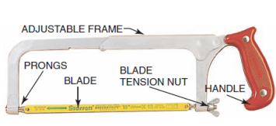
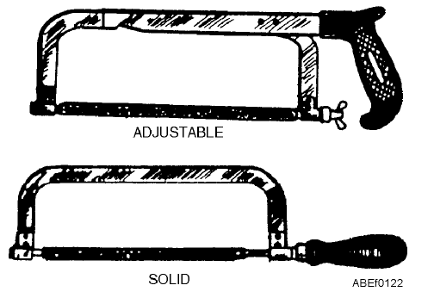
Using Hacksaws
The hacksaw is often used improperly. Although it can be used with limited success by an inexperienced person, a little thought and study given to its proper use will result in faster and better work and in less dulling and breaking of blades.
Good work with a hacksaw depends not only upon the proper use of the saw but also upon the proper selection of the blades for the work to be done. Coarse blades, with fewer teeth per inch, cut faster and are less likely to choke up with chips. However, finer blades, with more teeth per inch, are necessary when thin sections are being cut. The selection should be made so that, as each tooth starts its cut, the tooth ahead of it will still be cutting. To make the cut, first install the blade in the hacksaw frame so the teeth point away from the handle of the hacksaw. (Hand hacksaws cut on the push stroke.) Tighten the wing nut until the blade is definitely under tension. This helps make straight cuts. Push stroke.) Tighten the wing nut until the blade is definitely under tension. This helps make straight cuts

Place the material to be cut in a vise. A minimum of overhang will reduce vibration, give a better cut, and lengthen the life of the blade. Have the layout line outside of the vise jaw so that the line is visible while you work. The proper method of holding the hacksaw is depicted in figure 1-16. See how the index finger of the right hand, pointed forward, aids in guiding the frame. When cutting, let your body sway ahead and back with each stroke. Apply pressure on the forward stroke, which is the cutting stroke, but not on the return stroke. From 40 to 50 strokes per minute is the usual speed. Long, slow, steady strokes are preferred. For long cuts, rotate the blade in the frame so that the length of the cut is not limited by the depth of the frame. Hold the work with the layout line close to the vise jaws, raising the work in the vise as the sawing
Proceeds. To remove a frozen nut with a hacksaw, saw into the nut, starting the blade close to the threads on the bolt or stud and parallel to one face of the nut, as shown in view A. Saw parallel to the bolt until the teeth of the blade almost reach the lock washer. Lock washers are hard and will ruin hacksaw blades, so do not try to saw them. View B shows when to stop sawing. Then, with a cold chisel and hammer, remove this one side of the nut completely by opening the saw kerf. Put an adjustable wrench across this new flat and the one opposite, and again try to remove the frozen nut. Since very little original metal remains on this one side of the nut, the nut will either give or break away entirely and permit its removal. To saw a wide kerf in the head of a cap screw or machine bolt, fit the hand hacksaw frame with two blades side by side, and with teeth lined up in the same direction. With slow, steady strokes, saw the slot approximately one-third the thickness of the head of the cap screw. Such a slot will permit subsequent holding or turning with a screwdriver when it is impossible, due to close quarters, to use a wrench.

Hacksaw Safety
The main danger in using hacksaws is injury to your hand if the blade breaks. The blade will break if too much pressure is applied, when the saw is twisted, when the cutting speed is too fast, or when the blade becomes loose in the frame. Additionally, if the work is not tight in the vise, it will sometimes slip, twisting the blade enough to break it.

Hacksaw safety tips
- Always wear safety goggles while using a hacksaw.
- Be sure the hacksaw blade is properly tensioned.
- Do not brush away chips with your hand; use a brush.
- Never test the sharpness of a blade by running your fingers across its teeth.
- Keep saw blades clean, and use light machine oil on the blade to keep it from overheating and breaking.
HAMMERS
Main parts of a hammer
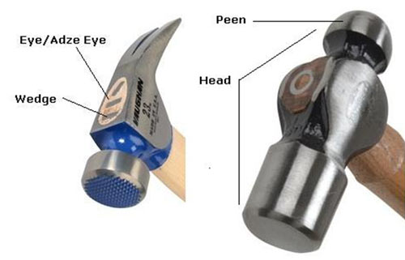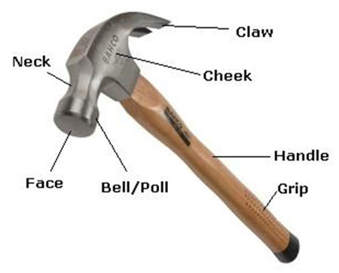
Safety advice when using hammers

- Wear goggles-especially when you are driving nails, breaking concrete or other materials that could shutter or fragment on impact.
- Always use the head of the hammer not the side to strike with. The metal is not hardened here, is much thinner where the handle passes through and can be damaged.
- The face can become polished with use and can slip off nails when struck, roughen the face with some abrasive paper to prevent slipping.
- Always use the right hammer for the job you are undertaking. it will make the work easier and will help to avoid possible damage to the hammer, yourself and the project you are working on.
- If a timber handle does start become loose, place the head in water overnight, the water will cause the handle to expand and tighten in the head
- Where the handle is held in the hammer head by steel wedges, check regularly to ensure the wedges are tight. Timber handle can shrink in dry conditions.
- Use a nail punch to sink nails into the timber, again this will prevent damage to the work piece. A nail punch has a flat end (or slightly, concave) to fit the nail head rather than the pointed end which other punches have.
- When assembling delicate work, use a piece of scrap wood between the work piece and the head of the hammer. This will prevent damage to the work piece.

Types of hammers

Claw Hammer
The most popular hammer for general work, available with a wooden (often hickory), glass-fiber or steel handle; with or without rubber grip. The most popular weights are 455-680g (16 to 24oz). The claw is normally curved, and incorporates a 'V' cut-out to draw nails from timber. The claw can be used to lever up floorboards or where other places where a lever is required; care must be taken (especially with cheaper models) as the force applied can easily weaken the joint between the handle and the head.

Ball Peen
Normally used by engineers, the peen in this case, is rounded and is usually used for shaping metal and closing rivets. Ball peen hammers are available from 55 - 1100 (4 or up to 2 lb.), 110 - 165g (8oz 12oz) are the most suitable for general use. Handles are normally wood, usually Ash or Hickory

Cross and Straight Peen
Again, mainly used for shaping metal, the peen can be at right angles to the handle or parallel with it. The most useful domestically is the cross peen, where the peen can be used for starting panel pins and tacks. Handles are normally wood, usually Ash.
Cross Pein Pin Hammer
A lighter version of the Cross and Straight Pein hammer, ideal for light joinery and cabinet work. Weight 55g (4oz).

Club Hammer
Sometimes called a Lump Hammer, it has a double faced head, and is useful for light demolition work, driving steel chisels and masonry nails. As debris is likely to fly, the wearing of safety glasses and working gloves is recommended. Weight 1135g (2 1/2 lb) being best suited to domestic work. Handles are normally wood, usually Hickory, or synthetic resin.

Sledge Hammer
Used for the heavier jobs, such as driving in stakes or to break up concrete, stone or masonry. For lighter jobs just the weight of the head may be used for blows, but for heavier work, the hammer is swung like an axe. Wear suitable protective clothing, including safety glasses. Weights 7, 10 and 14 lb.
Joiner's Mallet
Used to drive chisels or to tap wood joints together, where a metal-faced hammer would cause damage or bruising. Note that the head is slightly tapered to ensure correct contact with the work. Both the handle and head are wood, usually Beech or Lignum Vitae.
Soft-faced Hammers
Various types are available, with hard and soft rubber, plastic or copper faces. Some come with a choice of faces which are interchangeable. Useful for striking materials such as chrome wing outs, where a steel face would cause damage. In some cases, can replace a mallet for cabinet work.
Special Hammers From here on, there are specialist hammers developed to meet the needs of various trades. These include a Brick Hammer for striking a bolster or splitting bricks; Woodcarving Mallet, with rounded body; Veneer Hammer, for pressing and tapping veneers into place; Upholsterer's hammer for driving tacks and nails in confined spaces, and Sprig Hammer, used by picture frame makers.
Power Hammers More often referred to as 'powered nails', these take the hard work out of fitting nails, staples etc. They are ideal where a large number of nails need to be fitted, such as fixing floorboards. They range from light duty (for use when fixing edge mouldings, picture frames etc.) to heavy duty nails, used to fix floorboards and garden decking etc.
CHISELS
Chisels are grouped according to the material they cut, either wood, metal, stone or brick. The two main types are wood and cold.
Wood chisels have large, ergonomically shaped handles for a comfortable, sure grip and better control. Blades should be of high-quality carbon, heat-treated steel with precision-ground cutting edge. In addition, woodworking chisels should have crowned steel strike caps to help center the blow.
One type of wood chisel the butt chisel has a short blade that ranges from about 2-1/2" to 3" long. It is used by pattern makers, cabinetmakers, carpenters and do-it-yourselfers for carving and paring, particularly in tight spots. It can be used with hard-faced hammers.
A firmer chisel is square-sided and has a longer blade, usually from 3-1/2" to 6" and is used mainly for cutting deeply into wood. It should be used with soft-faced hammers.
Paring chisels are for light-duty, detailed work such as trimming cabinets.
Cold chisels have several styles—flat (the most widely used), cape, diamond-point and round-nose. They should be used only for cutting and chipping cold metal (unhardened steel, cast and wrought iron, aluminum, brass, copper), never masonry.
Bricklayer's chisels should be used when cutting masonry. Cold chisels should be struck only with a hand drilling, ball peen or similar heavy hammer with a face diameter approximately 3/8" larger than the struck tool head. Chisels have wood or plastic handles. Wood handles are available in both tang (the end of the blade or tang fits into the handle) and socket type (a projection from the handle fits into a socket in the blade). Plastic handles fit only tang construction. Like chisels and planes, gouges are used for removing material from a block of wood, plastic or metal. Gouges come in two primary types: inside and outside gouges. All steel chisels and punches (not wood chisels having wooden or plastic handles) are subject to chipping that can cause bodily injury much the same as steel hammer faces. Therefore, applicable safety standards require the warning "Wear Safety Goggles" on each tool. Nearly all domestic manufacturers comply by stamping those words into the shank.
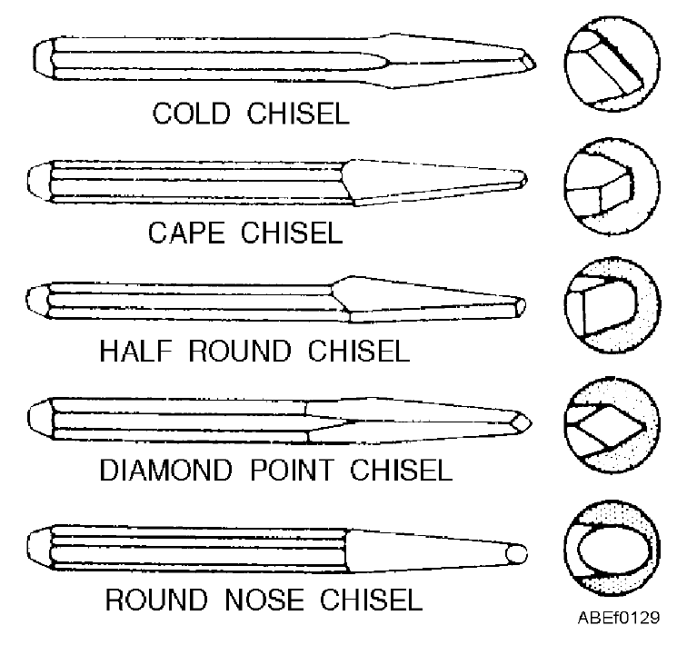

The type of chisel most commonly used is the flat cold chisel, which serves to cut rivets, split nuts, chip castings, and cut thin metal sheets. The cape chisel is used for special jobs like cutting keyways, narrow grooves, and square corners. Round-nose chisels make circular grooves and chip inside corners. Finally, the diamond-point is used for cutting V-grooves and sharp corners. As with other tools, there is a correct technique for using a chisel. Select a chisel that is large enough for the job. Be sure to use a hammer that matches the chisel; that is, the larger the chisel, the heavier the hammer. A heavy chisel will absorb the blows of a light hammer and will do virtually no cutting. When using a chisel for chipping, always wear goggles to protect your eyes. If others are working close by, see that they are protected from flying chips by erecting a screen or shield to contain the chips.

VISES
The size of a vise is measured by both the jaw width of the vise and the capacity of the vise when the jaws are fully open.

Bench vises are designed for light work in the home, garage and farm. They come in stationary and swivel models, milled and ground jaws, machined to ensure proper operation.

Woodworking vises feature jaws made of wood from 6" to 10" wide. Some woodworking vises have a fast-acting screw arrangement for the rapid positioning of the movable jaw prior to clamping. Smaller vises have continuous screws and are light and easy to clamp on a workbench or sawhorse. A hinged pipe vise is used to hold pipe in position for threading and cutting.
Utility vises have jaws ranging from 3" to 6". Better models feature swivel bases so the vise may be turned to the best angle for each particular job. Some utility vises either have cast in pipe jaws or permit special curved-face pipe jaws to be inserted between the regular jaws to add versatility.

A clamp vise is a combination fixed and portable vise, featuring a bottom clamp for easy attachment to workbenches, sawhorses or tables.

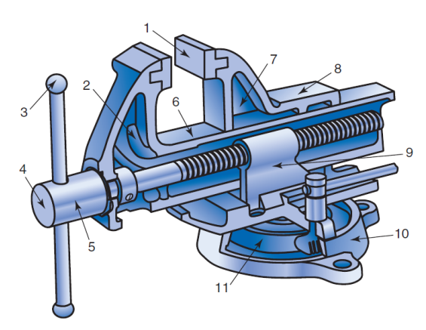

(1) Replaceable hardened tool steel faces pinned to jaw; (2) malleable iron front jaw;
(3) Steel handle with ball ends;
(4) cold-rolled steel screw;
(5) Bronze thrust bearing;
(6) Front jaw beam;
(7) Malleable iron back jaw body;
(8) Anvil;
(9) Nut, mounted in back jaw key seat for precise alignment;
(10) Malleable iron swivel base;
(11) Steel tapered gear and lock bolt.

TOPIC THREE
ENGINES
It is a machine that converts various forms of energy into mechanical energy or power to produce force and motion.
TYPES OF ENGINES
Internal combustion engine
- Reciprocating engines
- Rotary engines
External combustion engines
- Steam engines
Internal combustion engine
An internal combustion engine (ICE) is a heat engine where the combustion of a fuel occurs with an oxidizer (usually air) in a combustion chamber that is an integral part of the working fluid flow circuit. In an internal combustion engine the expansion of the high-temperature and high-pressure gases produced by combustion applies direct force to some component of the engine. The force is applied typically to pistons, turbine blades, rotor or a nozzle. This force moves the component over a distance, transforming chemical energy into useful mechanical energy.

There are several possible ways to classify internal combustion engines.
Reciprocating:
By number of strokes
- Two-stroke engine
- Four-stroke engine (Otto cycle)
- Six-stroke engine
By type of ignition
- Compression-ignition engine
- Spark-ignition engine (commonly found as gasoline engines)
Rotary:
Continuous combustion:
- Gas turbine
- Jet engine
- Rocket engine
- Ramjet
The following jet engine types are also gas turbines types:
- Turbojet
- Turbofan
- Turboprop

FOUR STROKE ENGINES
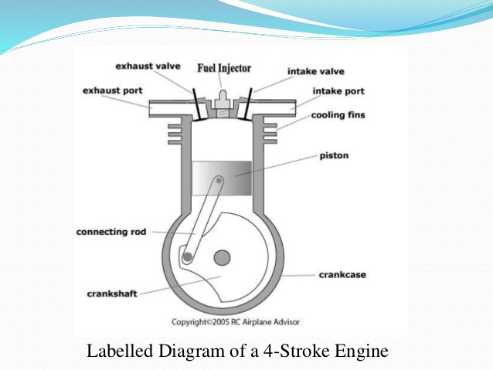
Four stroke diesel engine
Special features of diesel engine
- Engine has high compression ratio ranging from 14:1 to 22:1.
- During compression stroke, the engine attains high pressure ranging from 30 to 45 kg/cm2 and high temperature of about 500°C.
- At the end of the compression stroke, fuel is injected into the cylinder through injectors (atomizers) at a very high pressure ranging from 120 to 200 kg/cm2.
- Ignition takes place due to heat of compression only.
- There is no external spark in diesel engine.
- Diesel engine has better slogging or lugging ability i.e. it maintains higher torque for a longer duration of time at a lower speed.
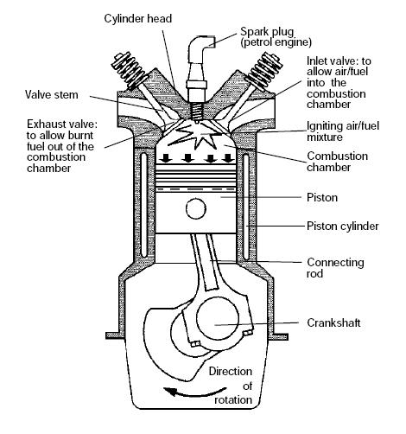
Four stroke petrol engine

ENGINE COMPONENTS
Internal combustion engine consists of a number of parts which are given below:
i) Cylinder: It is a part of the engine which confines the expanding gases and forms the combustion space. It is the basic part of the engine. It provides space in which piston operates to suck the air or air-fuel mixture. The piston compresses the charge and the gas is allowed to expand in the cylinder, transmitting power for useful work. Cylinders are usually made of high grade cast iron.

ii) Cylinder block: It is the solid casting body which includes the cylinder and water jackets (cooling fins in the air cooled engines).

iii) Cylinder head: It is a detachable portion of an engine which covers the cylinder and includes the combustion chamber, spark plugs or injector and valves.

iv) Cylinder liner or sleeve: It is a cylindrical lining either wet or dry type which is inserted in the cylinder block in which the piston slides. Liners are classified as: (1) Dry liner and (2) Wet liner. Dry liner makes metal to metal contact with the cylinder block casing. Wet liners come in contact with the cooling water, whereas dry liners do not come in contact with the cooling water.

v) Piston: It is a cylindrical part closed at one end which maintains a close sliding fit in the engine cylinder. It is connected to the connecting rod by a piston pin. The force of the expanding gases against the closed end of the piston, forces the piston down in the cylinder. This causes the connecting rod to rotate the crankshaft (Fig 3). Cast iron is chosen due to its high compressive strength. Aluminum and its alloys preferred mainly due to it lightness.

Head (Crown) of piston: It is the top of the piston.
Skirt: It is that portion of the piston below the piston pin which is designed to adsorb the side movements of the piston.

vi) Piston ring: It is a split expansion ring, placed in the groove of the piston. They are usually made of cast iron or pressed steel alloy (Fig.3). The function of the ring are as follows:
a) It forms a gas tight combustion chamber for all positions of piston.
b) It reduces contact area between cylinder wall and piston wall preventing Friction losses and excessive wear.
c) It controls the cylinder lubrication.
d) It transmits the heat away from the piston to the cylinder walls. Piston rings are of two types: (1) Compression ring and (2) Oil ring

vii) Compression ring
Compression rings are usually plain, single piece and are always placed in the grooves of the piston nearest to the piston head. They prevent leakage of gases from the cylinder and helps increasing compression pressure inside the cylinder.

Oil ring: Oil rings are grooved or slotted and are located either in lowest groove above the piston pin or in a groove above the piston skirt. They control the distribution of lubrication oil in the cylinder and the piston.

Piston Pin: It is also called wrist pin or gudgeon pin. Piston pin is used to join the connecting rod to the piston.

viii) Connecting rod: It is special type of rod, one end of which is attached to the piston and the other end to the crankshaft. It transmits the power of combustion to the crankshaft and makes it rotate continuously. It is usually made of drop forged steel.

ix) Crankshaft: It is the main shaft of an engine which converts the reciprocating motion of the piston into rotary motion of the flywheel. Usually the crankshaft is made of drop forged steel or cast steel. The space that supports the crankshaft in the cylinder block is called main journal, whereas the part to which connecting rod is attached is known as crank journal. Crankshaft is provided with counter weights throughout its length to have counter balance of the unit.

x) Flywheel: Flywheel is made of cast iron. Its main functions are as follows:
a) It stores energy during power stroke and returns back the energy during the idle strokes, providing a uniform rotary motion of flywheel.
b) The rear surface of the flywheel serves as one of the pressure surfaces for the clutch plate.
c) Engine timing marks are usually stamped on the flywheel, which helps in adjusting the timing of the engine.
d) Sometime the flywheel serves the purpose of a pulley for transmitting power.

xi) Crankcase: The crankcase is that part of the engine which supports and encloses the crankshaft and camshaft. It provides a reservoir for the lubricating oil. It also serves as a mounting unit for such accessories as the oil pump, oil filter,, starting motor and ignition components. The upper portion of the crankcase is usually integral with cylinder block. The lower part of the crankcase is commonly called oil pan and is usually made of cast iron or cast aluminum

xii) Camshaft: It is a shaft which raises and lowers the inlet and exhaust valves at proper times. Camshaft is driven by crankshaft by means of gears, chains or sprockets (Fig3). The speed of the camshaft is exactly half the speed of the crankshaft in four stroke engine. Camshaft operates the ignition timing mechanism, lubricating oil pump and fuel pump. It is mounted in the crankcase, parallel to the crankshaft.

xiii) Timing gear: Timing gear is a combination of gears, one gear of which is mounted at one end of the camshaft and the other gear at the crankshaft. Camshaft gear is bigger in size than that of the crankshaft gear and it has twice as many teeth as that of the crankshaft gear. For this reason, this gear is commonly called half time gear. Timing gear controls the timing of ignition, timing of opening and closing of valve as well as fuel injection timing.

xiv) Inlet manifold: It is that part of the engine through which air or air-fuel mixture enters into the engine cylinder. It is fitted by the side of the cylinder head.

xv) Exhaust manifold: It is that part of the engine through which exhaust gases go out of the engine cylinder. It is capable of withstanding high temperature of burnt gases.
It is fitted by the side of the cylinder head.

xiv) Top dead Centre - When the piston is at the top of its stroke, it is said to be at the top dead Centre (TDC),

xv) Bottom dead Centre - when the piston is at the bottom of its stroke, it is said to be at its bottom dead Centre (BDC).
In two stroke cycle engine both the sides of the piston are effective which is not the case in four stroke cycle engine.
xvi) Scavenging
The process of removal of burnt or exhaust gases from the engine cylinder is known as scavenging. Entire burnt gases do not go out in normal stroke, hence some type of blower or compressor is used to remove the exhaust gases in two stroke cycle engine.

Operation of four stroke engine
Intake, induction or suction:
The intake valves are open as a result of the cam lobe pressing down on the valve stem. The piston moves downward increasing the volume of the combustion chamber and allowing air to enter in the case of a CI engine or an air fuel mix in the case of SI engines that do not use direct injection. The air or air-fuel mixture is called the charge in any case.
Compression:
In this stroke, both valves are closed and the piston moves upward reducing the combustion chamber volume which reaches its minimum when the piston is at TDC. The piston performs work on the charge as it is being compressed; as a result its pressure, temperature and density increase; an approximation to this behavior is provided by the ideal gas law. Just before the piston reaches TDC, ignition begins. In the case of a SI engine, the spark plug receives a high voltage pulse that generates the spark which gives it its name and ignites the charge. In the case of a CI engine the fuel injector quickly injects fuel into the combustion chamber as a spray; the fuel ignites due to the high temperature.
Power or working stroke:
The pressure of the combustion gases pushes the piston downward, generating more work than it required to compress the charge. Complementary to the compression stroke, the combustion gases expand and as a result their temperature, pressure and density decreases. When the piston is near to BDC the exhaust valve opens. The combustion gases expand irreversibly due to the leftover pressure—in excess of back pressure, the gauge pressure on the exhaust port—; this is called the blow down.
Exhaust:
The exhaust valve remains open while the piston moves upward expelling the combustion gases. For naturally aspirated engines a small part of the combustion gases may remain in the cylinder during normal operation because the piston does not close the combustion chamber completely; these gases dissolve in the next charge. At the end of this stroke, the exhaust valve closes, the intake valve opens, and the sequence repeats in the next cycle. The intake valve may open before the exhaust valve closes to allow better scavenging.

TWO STROKE ENGINE
In two stroke cycle engines, the whole sequence of events i.e., suction, compression, power and exhaust are completed in two strokes of the piston i.e. one revolution of the crankshaft. There is no valve in this type of engine. Gas movement takes place through holes called ports in the cylinder. The crankcase of the engine is air tight in which the crankshaft rotates

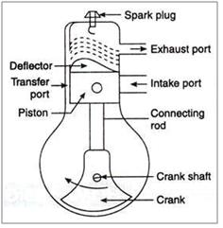

OPERATION OF A TWO STROKE ENGINES
Upward stroke of the piston (Suction + Compression)
When the piston moves upward it covers two of the ports, the exhaust port and transfer port, which are normally almost opposite to each other. This traps the charge of air- fuel mixture drawn already in to the cylinder. Further upward movement of the piston compresses the charge and also uncovers the suction port. Now fresh mixture is drawn through this port into the crankcase. Just before the end of this stroke, the mixture in the cylinder is ignited by a spark plug (Fig 2 c &d). Thus, during this stroke both suction and compression events are completed.

Downward stroke (Power + Exhaust)
Burning of the fuel rises the temperature and pressure of the gases which forces the piston to move down the cylinder. When the piston moves down, it closes the suction port, trapping the fresh charge drawn into the crankcase during the previous upward stroke. Further downward movement of the piston uncovers first the exhaust port and then the transfer port. Now fresh charge in the crankcase moves in to the cylinder through the transfer port driving out the burnt gases through the exhaust port. Special shaped piston crown deflect the incoming mixture up around the cylinder so that it can help driving out the exhaust gases. During the downward stroke of the piston power and exhaust events are completed.

DIFFERENCES BETWEEN TWO STROKE AND FOUR STROKE ENGINES
NO | DESCRIPTION | TWO STROKE | FOUR STROKE
1 | Valves | Doesn’t have valves because intake and exhaust are part of the compression and combustion of the piston. Instead there is an exhaust port in the combustion chamber. | Have valves because each stroke takes part individually and in a systematic way.
2 | Oil chamber | Doesn’t have a different oil chamber hence oil must be mixed with fuel in proper amounts. | Have a separate oil chamber therefore oil isn’t mixed with fuel.
3 | Noise | Produces more noise | Produces less noise
4 | Fuel | Uses petrol | Both diesel and petrol
5 | Weight | Light in weight | Size and weight of the engine is heavy and larger
6 | Working stroke | One working stroke in each cylinder per revolution of crank shaft | One working stroke in each cylinder per two revolution of crank shaft
7 | Moving parts | Moving parts are few | Moving parts are more
8 | Mechanical efficiency | It is more | It is less
9 | Thermal efficiency | It is less because a part of the air fuel mixture gas as waste with the exhaust gas | It is more
10 | Wear and tear | Is more due to the smaller size of the same power | Is less
11 | Construction | It is simple and easy to manufacture | More complicated due to valve mechanism.

DIFFERENCES BETWEEN DIESEL AND PETROL ENGINES
NO | DESCRIPTION | DIESEL | PETROL
1 | Ignition | Self-ignited | Uses a spark plug
2 | Compression ratio | High 14:1 to 22:1 | Low 5:1 to 8:1
3 | Air fuel mix | Fuel is first fed into the cylinder by a fuel injector and then gets mixed with air inside the cylinder | Air and petrol are mixed in a carburetor and enters into the cylinder.
4 | Area of application | In heavy vehicles like buses, trucks etc. | In light weight vehicles like car , motorcycles etc.
5 | Weight | Heavy | Light
6 | Initial Maintenance | High cost of initial and maintenance | Lowered cost of initial cost and maintenance
7 | Starting problem | Greater | Leaser
8 | Fuel consumption | Less | High
9 | Power produce | More power produced due to higher compression ratio | Less power produced due to lower compression ratio

MODEL QUESTIONS
1. List the advantages of diesel engine
2. Mention the basic components of an IC Engine
3. List the types of engine classification
4. Mention the four strokes of IC engine with a neat sketch and explain their role
5. Differentiate petrol and diesel engine
6. Mention merits and demerits of different farm power sources.
7. Differentiate IHP and BHP
8. Write about the working of four stroke cycle engine
9. Write about the working of two stroke cycle engine
10. Compare four stroke cycle engine with two stroke cycle engine
11. Compare spark ignition engine with compression engine

THE CARBURATORS
In s.i engines air and fuel are mixed outside the cylinder then supplied to the cylinder for producing power
Carburetor is the device that blends air and fuel for an internal combustion engine.
Functions of a carburetor
- It combines gasoline and air creating a highly combustible mixture
- It regulates the ratio of air and fuel
- It controls the engine's speed.

How a carburetor mixes fuel and air
When the piston moves down the cylinder on the intake stroke it draws air from the cylinder and intake manifold. A vacuum is created that draws air from the carburetor. The airflow through the carburetor causes fuel to be drawn from the carburetor through the intake manifold past the intake valves and into the cylinder. The amount of fuel mixed into the air to obtain the required air to fuel ratio is controlled by the venturi or choke. When air flows through the venturi its speed increases and the pressure drops. This causes the fuel to be sucked into the air stream from a hole or jet. When the engine is at idle or at rapid acceleration there is not enough air passing through the venturi to draw fuel. Problems To overcome these problems other systems are used. Other systems are used.

Delivering gasoline to the carburetor
Gasoline is delivered to the carburetor by the fuel pump and is stored in the fuel bowl. To keep this level of fuel stored in the bowl constant under all conditions a float system is used. A float operated needle valve and seat at the fuel inlet is used to control the fuel level in the bowl. If the fuel level drops below a certain level the float lowers and opens the valve letting more fuel in. When the float rises it pushes the inlet valve against the seat and shuts off the flow of fuel into the bowl.

Controlling the speed of the engine
The throttle controls the speed of the engine by controlling the amount of air fuel allowed in the engine. The throttle is a butterfly valve located after the venturi and is opened by pressing on the gas pedal. The farther the valve is opened the more air/fuel mixture is let into the engine and the faster the engine runs. At low engine speeds when the throttle is only open a little there is not enough air flow to pull in fuel.

Ports
Two ports are used to solve this problem. One port located in the low pressure area and the idle port located below. At low engine speeds both ports draw fuel to keep the engine running. As engine speed increases fuel from the 2 ports decreases until it stops completely.

Handling low speeds
When the engine is idle there is very little air flowing through the venturi because the throttle valve is closed. The idle port allows the engine to operate under this condition. Fuel is forced through the idle port because of a pressure differential between air in the fuel bowl and vacuum below the throttle valve. Idle fuel mixture is controlled by an adjustable needle valve.

Handling high speeds
At higher engine speeds more fuel is drawn from the main nozzle. Fuel comes from the fuel bowl through the fuel nozzle and into the throat of the carburetor where it mixes with air.

TOPIC THREE
MACHINE TOOLS

LATHE MACHINE
INTRODUNCTION
Lathe is one of the most versatile and widely used machine tools all over the world. It is commonly known as the mother of all other machine tool. The main function of a lathe is to remove metal from a job to give it the required shape and size. The job is secure1y and rigid1y held in the chuck or in between centers on the lathe machine and then turn it against a single point cutting tool which wi1l remove meta1 from the job in the form of chips.
An engine lathe is the most basic and simplest form of the lathe. It derives its name from the early lathes, which obtained their power from engines. Besides the simple turning operation as described above, lathe can be used to carry out other operations also, such as drilling, reaming, boring, taper turning, knurling, and screw thread
Cutting, grinding etc.
TYPES OF LATHE
Lathes are manufactured in a variety of types and sizes, from very small bench lathes used for precision work to huge lathes used for turning large steel shafts. But the principle of operation and function of all types of lathes is same. The different types of lathes are:
1. Speed lathe
(a) Wood working
(b) Spinning
(c) Centering
(d) Po1ishing
2. Centre or engine lathe
(a) Be1t drive
(b) Individual motor drive
(c) Gear head lathe
3. Bench lathe
4. Tool room Lathe
5. Capstan and Turret 1athe
6. Special purpose lathe
(a) Whee1 lathe
(b) Gap bed lathe
(c) Dup1icating lathe
(d) T-lathe
7. Automatic lathe

Speed Lathe
Speed lathe is simplest of all types of lathes in construction and operation. The important parts of speed lathe are following-
(1) Bed
(2) Headstock
(3) Tailstock, and
(4) Tool post mounted on an adjustable slide.
It has no feed box, 1eadscrew or conventional type of carriage. The tool is mounted on the adjustable slide and is fed into the work by hand contro1. The speed lathe finds applications where cutting force is least such as in wood working, spinning, centering, polishing, winding, buffing etc.
This lathe has been so named because of the very high speed of the headstock spindle.

Centre Lathe or Engine Lathe
The term “engine” is associated with this lathe due to the fact that in the very early days of its development it was driven by steam engine. This lathe is the important member of the lathe family and is the most widely used. Similar to the speed lathe, the engine lathe has all the basic parts, e.g., bed, headstock, and tailstock. But its headstock is much more robust in construction and contains additional mechanism for driving the lathe spindle at multiple speeds.. Unlike the speed lathe, the engine lathe can feed the cutting tool both in cross and longitudinal direction with reference to the lathe axis with the help of a carriage, feed rod and lead screw. Centre lathes or engine lathes are classified according to methods of transmitting power to the machine. The power may be transmitted by means of belt, electric motor or through gears.
Bench Lathe
This is a small lathe usually mounted on a bench. It has practically all the parts of an engine lathe or speed lathe and it performs almost all the operations. This is used for small and precision work.

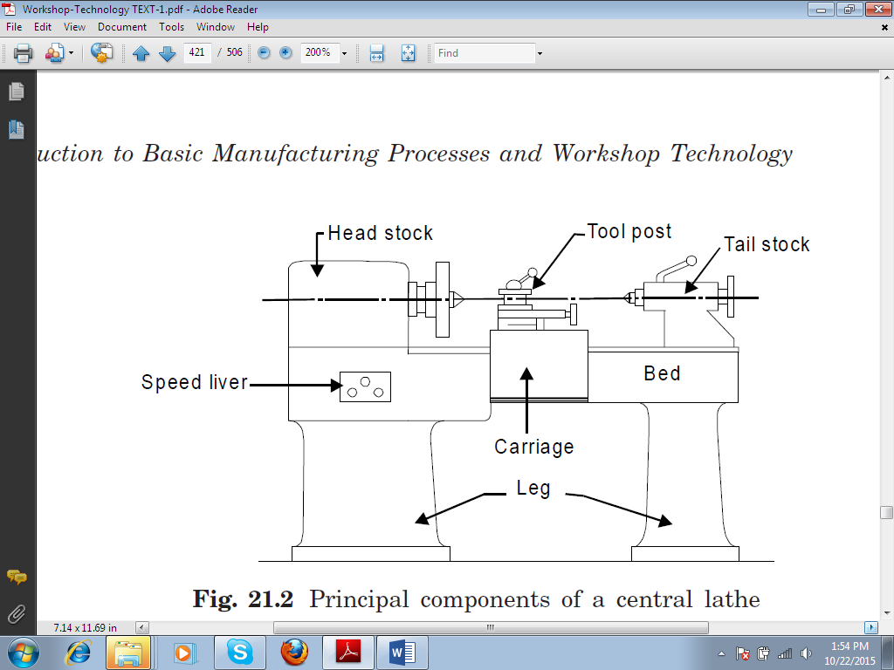
Principal components of a lathe machine

Tool Room Lathe
This lathe has features similar to an engine lathe but it is much more accurately built. It has a wide range of spindle speeds ranging from a very low to a quite high speed up to 2500 rpm. This lathe is mainly used for precision work on tools, dies, gauges and in machining work where accuracy is needed.

Capstan and Turret Lathe
The development of these 1athes results from the technological advancement of the engine lathe and these are vastly used for mass production work. The distinguishing feature of this type of lathe is that the tailstock of an engine lathe is replaced by a hexagonal turret, on the face of which multiple tools may be fitted and fed into the work in proper sequence. Due to this arrangement, several different types of operations can be done on a job without re-setting of work or tools, and a number of identical parts can be produced in the minimum time.

Special Purpose Lathes
These lathes are constructed for special purposes and for jobs, which cannot be accommodated or conveniently machined on a standard lathe. The wheel lathe is made for finishing the journals and turning the tread on railroad car and locomotive wheels. The gap bed lathe, in which a section of the bed adjacent to the headstock is removable, is used to swing extra-large-diameter pieces. The T-lathe is used for machining of rotors for jet engines.
The bed of this lathe has T-shape. Duplicating lathe is one for duplicating the shape of a flat or round template on to the job.

Automatic Lathes
These lathes are so designed that all the working and job handling movements of the complete manufacturing process for a job are done automatically. These are high speed, heavy duty, mass production lathes with complete automatic control.

Safety Precautions while Working on Lathe Machine
1. One should always be sure that all guards are in place before running the machine.
2. Always clamp the work and tool properly with correct size of work and tool holding device.
3. Always keep the machine clear of tools.
4. Machine should be stopped before making measurements or adjustments.
5. Wear an apron or a properly fitted shop coat. Goggles should also be used.
6. One should remove necktie, wrist watch and jewelry while working.
7. One should not operate the lathe until he knows the proper procedure.
8. One should check the work frequently when it is being machined.
9. One should check the face-plate or chuck by hand to be sure that there is no danger of the work striking any part of the lathe.
10. Stop the machine and remove chips with pliers. One should not remove the chips by hand.

SHAPER
Shaper is a reciprocating type of machine tool in which the ram moves the cutting tool backwards and forwards in a straight line. The basic components of shaper are shown in the fig below. It is intended primarily to produce flat surfaces. These surfaces may be horizontal, vertical, or inclined. In general, the shaper can produce any surface composed of straight-line elements.

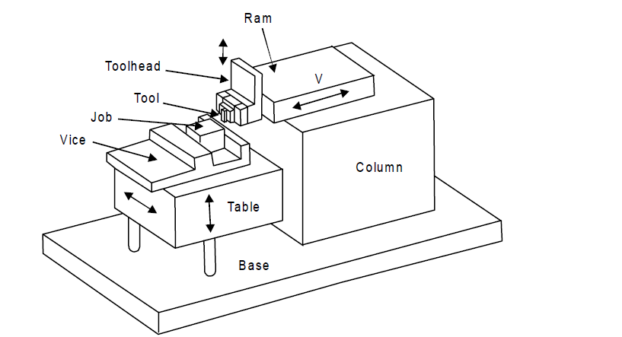
Principal components of a shaper machine

WORKING PRINCIPLE OF SHAPER
A single point cutting tool is held in the tool holder, which is mounted on the ram. The work piece is rigidly held in a vice or clamped directly on the table. The table may be supported at the outer end. The ram reciprocates and thus cutting tool held in tool holder moves forward and backward over the work piece. In a standard shaper, cutting of material takes place during the forward stroke of the ram. The backward stroke remains idle and no cutting takes place during this stroke. The feed is given to the work piece and depth of cutis adjusted by moving the tool downward towards the work piece. The time taken during the idle stroke is less as compared to forward cutting stroke and this is obtained by quick return mechanism. The cutting action and functioning of clapper box is during forward and return stroke.

TYPES OF SHAPERS
Shapers are classified under the following headings:
(1) According to the type of mechanism used for giving reciprocating motion to the ram
(a) Crank type
(b) Geared type
(c) Hydraulic type
(2) According to the type of design of the table:
(a) Standard shaper
(b) Universal shaper
(3) According to the position and travel of ram:
(a) Horizontal type
(b) Vertical type
(c) Traveling head type
(4) According to the type of cutting stroke:
(a) Push type
(b) Draw type.
A brief description these shapers is given below-
Crank Shaper
This is the most common type of shaper. It employs a crank mechanism to change circular motion of a large gear called “bull gear” incorporated in the machine to reciprocating motion of the ram. The bull gear receives power either from an individual motor or from an overhead line shaft if it is a belt-driven shaper.
Geared Shaper
Geared shaper uses rack and pinion arrangement to obtain reciprocating motion of the ram. Presently this type of shaper is not very widely used.
Hydraulic Shaper
In hydraulic shaper, reciprocating motion of the ram is obtained by hydraulic power. For generation of hydraulic power, oil under high pressure is pumped into the operating cylinder fitted with piston. The piston end is connected to the ram through piston rod. The high pressure oil causes the piston to reciprocate and this reciprocating motion is transferred to the ram of shaper. The important advantage of this type of shaper is that the cutting speed and force of the ram drive are constant from the very beginning to the end of the cut.
Standard Shaper
In standard shaper, the table has only two movements, horizontal and vertical, to give the feed.
Universal Shaper
A universal shaper is mostly used in tool room work. In this type of shaper, in addition to the horizontal and vertical movements, the table can be swiveled about an axis parallel to the ram ways, and the upper portion of the table can be tilted about a second horizontal axis perpendicular to the first axis.
Horizontal Shaper
In this type of shaper, the ram holding the tool reciprocates in a horizontal axis.
Vertical Shaper
In vertical shaper, the ram reciprocates in a vertical axis. These shapers are mainly used for machining keyways, slots or grooves, and internal surfaces.
Travelling Head Shaper
In this type of shaper, the ram while it reciprocates, also moves crosswise to give the required feed.
Push Type Shaper
This is the most general type of shaper used in common practice, in which the metal is removed when the ram moves away from the column, i.e. pushes the work.
Draw Type Shaper
In this type of shaper, the cutting of metal takes place when the ram moves towards the column of the machine, i.e. draws the work towards the machine. The tool is set in a reversed direction to that of a standard shaper.

PRINCIPAL PARTS OF SHAPER

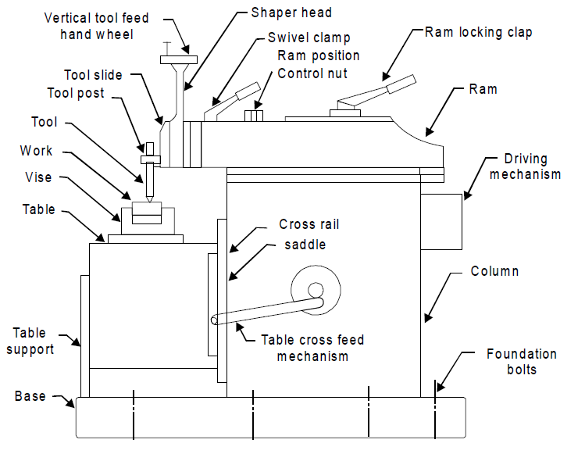
Parts of a shaper
Base
It is rigid and heavy cast iron body to resist vibration and takes up high compressive load. It supports all other parts of the machine, which are mounted over it. The base may be rigidly bolted to the floor of the shop or on the bench according to the size of the machine.
Column
The column is a box shaped casting mounted upon the base. It houses the ram-driving mechanism. Two accurately machined guide ways are provided on the top of the column on which the ram reciprocates.
Cross rail
Cross rail of shaper has two parallel guide ways on its top in the vertical plane that is perpendicular to the rai1 axis. It is mounted on the front vertical guide ways of the column. It consists mechanism for raising and lowering the table to accommodate different sizes of jobs by rotating an elevating screw which causes the cross rail to slide up and down on the vertical face of the column. A horizontal cross feed screw is fitted within the cross rail and parallel to the top guide ways of the cross rail. This screw actuates the table to move in a crosswise direction.
Saddle
The saddle is located on the cross rail and holds the table on its top. Crosswise movement of the saddle by rotation the cross feed screw by hand or power causes the table to move sideways.
Table
The table is a box like casting having T -slots both on the top and sides for clamping the work. It is bolted to the saddle and receives crosswise and vertical movements from the saddle and cross rail.
Ram
It is the reciprocating part of the shaper, which reciprocates on the guide ways provided above the column. Ram is connected to the reciprocating mechanism contained within the column.
Tool head
The tool head of a shaper performs the following functions-
(1) It holds the tool rigidly,
(2) It provides vertical and angular feed movement of the tool, and
(3) It allows the tool to have an automatic relief during its return stroke.
The various parts of tool head of shaper are apron clamping bolt, clapper box, tool post, down feed, screw micrometer dial, down feed screw, vertical slide, apron washer, apron swivel pin, and swivel base. By rotating the down feed screw handle, the vertical slide carrying the tool gives down feed or angular feed movement while machining vertical or angular surface.
The amount of feed or depth of cut may be adjusted by a micrometer dial on the top of the down feed screw. Apron consisting of clapper box, clapper block and tool post is clamped upon the vertical slide by a screw. The two vertical walls on the apron called clapper box houses the clapper block, which is connected to it by means of a hinge pin. The tool post is mounted upon the clapper block. On the forward cutting stroke the clapper block fits securely to the clapper box to make a rigid tool support. On the return stroke a slight frictional drag of the tool on the work lifts the block out of the clapper box a sufficient amount preventing the tool cutting edge from dragging and consequent wear. The work surface is also prevented from] any damage due to dragging.

SHAPER OPERATIONS
A shaper is a machine tool primarily designed to generate a flat surface by a single point cutting tool. Besides this, it may also be used to perform many other operations. The different operations, which a shaper can perform, are as follows:
1. Machining horizontal surface (Fig. 23.7)
2. Machining vertical surface (Fig. 23.8)
3. Machining angular surface (Fig. 23.9)
4. Slot cutting (Fig. 23.10)
5. Key ways cutting (Fig. 23.11)
6. Machining irregular surface (Fig. 23.12)
7. Machining splines and cutting gears (Fig. 23.13)

MILLING MACHINE
Milling machines assisted man in maintaining accuracy and uniformity while duplicating parts that could not be manufactured with the use of a file. Development and improvements of the milling machine and components continued, which resulted in the manufacturing of heavier arbors and high speed steel and carbide cutters. These components allowed the operator to remove metal faster, and with more accuracy, than previous machines.
General. The milling machine removes metal with a revolving cutting tool called a milling cutter. With various attachments, milling machines can be used for boring, slotting, circular milling dividing, and drilling. This machine can also be used for cutting keyways, racks and gears and for fluting taps and reamers.
Types. Milling machines are basically classified as being horizontal or vertical to indicate the axis of the milling machine spindle. These machines are also classified as knee-type, ram-type, manufacturing or bed type, and planer-type milling machines. Most machines have self-contained electric drive motors, coolant systems, variable spindle speeds, and power operated table feeds.

Knee-type Milling Machines. Knee-type milling machines are characterized by a vertical adjustable worktable resting on a saddle supported by a knee. The knee is a massive casting that rides vertically on the milling machine column and can be clamped rigidly to the column in a position where the milling head and the milling machine spindle are properly adjusted vertically for operation.

- The floor-mounted plain horizontal milling machine's column contains the drive motor and, gearing and a fixed-position horizontal milling machine spindle. An adjustable overhead arm, containing one or more arbor supports, projects forward from the top of the column. The arm and arbor supports are used to stabilize long arbors, upon which the milling cutters are fixed. The arbor supports can be moved along the overhead arm to support the arbor wherever support is desired. This support will depend on the location of the milling cutter or cutters on the arbor.
The knee of the machine rides up or down the column on a rigid track. A heavy, vertical positioned screw beneath the knee is used for raising and lowering. The saddle rests upon the knee and supports the worktable. The saddle moves in and out on a dovetail to control the cross feed of the worktable. The worktable traverses to the right or left upon the saddle, feeding the work piece past the milling cutter. The table may be manually controlled or power fed.

- Bench-type Plain Horizontal Milling Machine. The bench-type plain horizontal milling machine is a small version of the floor-mounted plain horizontal milling machine; it is mounted to a bench or a pedestal instead of directly to the floor. The milling machine spindle is horizontal and fixed in position. An adjustable overhead arm and support are provided. The worktable is generally not power fed on this size machine. The saddle slides on a dovetail on the knee providing cross feed adjustment. The knee moves vertically up or down the column to position the worktable in relation to the spindle.

- Floor-mounted Universal Horizontal Milling Machine. The basic difference between a universal horizontal milling machine and a plain horizontal milling machine is in the adjustment of the worktable, and in the number of attachments and accessories available for performing various special milling operations. The universal horizontal milling machine has a worktable that can swivel on the saddle with respect to the axis of the milling machine spindle, permitting work pieces to be adjusted in relation to the milling cutter.

The universal horizontal milling machine also differs from the plain horizontal milling machine in that it is of the ram type; i.e., the milling machine spindle is in a swivel cutter head mounted on a ram at the top of the column. The ram can be moved in or out to provide different positions for milling operations.

Ram-type Milling Machines.
The ram-type milling machine is characterized by a spindle mounted to a movable housing on the column, permitting positioning the milling cutter forward or rearward in a horizontal plane. Two widely used ram-type milling machines are the floor-mounted universal milling machine and the swivel cutter head ram-type milling machine.

- Swivel Cutter Head Ram-type Milling Machine. A cutter head containing the milling machine spindle is attached to the ram. The cutter head can be swiveled from a vertical to a horizontal spindle position, or can be fixed at any desired angular position between the vertical and horizontal. The saddle and knee are driven for vertical and cross feed adjustment; the worktable can be either hand driven or power driven at the operator's choice.

Parts of milling machine

- Column. The column, including the base, is the main casting which supports all other parts of the machine. An oil reservoir and a pump in the column keeps the spindle lubricated. The column rests on a base that contains a coolant reservoir and a pump that can be used when performing any machining operation that requires a coolant.
- Knee. The knee is the casting that supports the table and the saddle. The feed change gearing is enclosed within the knee. It is supported and can be adjusted by the elevating screw. The knee is fastened to the column by dovetail ways. The lever can be raised or lowered either by hand or power feed. The hand feed is usually used to take the depth of cut or to position the work, and the power feed to move the work during the machining operation.
- Saddle and Swivel Table. The saddle slides on a horizontal dovetail, parallel to the axis of the spindle, on the knee. The swivel table (on universal machines only) is attached to the saddle and can be swiveled approximately 45 in either direction.
- Power Feed Mechanism. The power feed mechanism is contained in the knee and controls the longitudinal, transverse (in and out) and vertical feeds. The desired rate of feed can be obtained on the machine by positioning the feed selection levers as indicated on the feed selection plates. On some universal knee and column milling machines the feed is obtained by turning the speed selection handle until the desired rate of feed is indicated on the feed dial. Most milling machines have a rapid traverse lever that can be engaged when a temporary increase in speed of the longitudinal, transverse, or vertical feeds is required. For example, this lever would be engaged when positioning or aligning the work. For safety reasons, extreme caution should be exercised while using the rapid traverse controls.
- Table. The table is the rectangular casting located on top of the saddle. It contains several T-slots for fastening the work or work holding devices. The table can be moved by hand or by power. To move the table by hand, engage and turn the longitudinal hand crank. To move it by power, engage the longitudinal directional feed control lever. The longitudinal directional control lever can be positioned to the left, to the right, or in the center. Place the end of the directional feed control lever to the left to feed the table to the left. Place it to the right to feed the table to the right. Place it in the center position to disengage the power feed, or to feed the table by hand.
- Spindle. The spindle holds and drives the various cutting tools. It is a shaft, mounted on bearings supported by the column. The spindle is driven by an electric motor through a train of gears, all mounted within the column. The front end of the spindle, which is near the table, has an internal taper machined on it. The internal taper (3 1/2 inches per foot) permits mounting tapered-shank cutter holders and cutter arbors. Two keys, located on the face of the spindle, provide a positive drive for the cutter holder, or arbor. The holder or arbor is secured in the spindle by a draw bolt and jam nut, as shown in figure 3 on the following page. Large face mills are sometimes mounted directly to the spindle nose.
- Overarm. The overarm is the horizontal beam to which the arbor support is fastened. The overarm, may be a single casting that slides in the dovetail ways on the top of the column. It may consist of one or two cylindrical bars that slide through the holes in the column. On some machines to position the overarm, first unclamp the locknuts and then extend the overarm by turning a crank. On others, the overarm is moved by merely pushing on it. The overarm should only be extended far enough to so position the arbor support as to make the setup as rigid as possible. To place the arbor supports on an overarm, extend one of the bars approximately 1-inch farther than the other bar.

Drilling machine

- Holes in the work piece are necessary for many purposes such as fastening the object with nuts and bolts, Screws, for fixing assembly purpose so it is necessary to make holes in the work piece. So the Drilling is a process of making a hole in the blank work piece, or enlarging the existing hole. The Machine which is used for this purpose is called as drilling machine. It consist of spindle which is rotated by the motor and transmitting mechanism, The spindle in turn rotates the drilling tool called as drill, as drill is press fitted into the spindle. Drill is fed into work by feed mechanism. The work piece is fixed on the table, as the drill fed into the work piece; the hole is created by removing material in the form of chips. All the components are supported by frame. Cutting fluid is commonly used to cool the drill bit, increase tool life, increase speeds and feeds, increase the surface finish, and aid in ejecting chips.

Parts of drilling machine

Base: base is the lowest horizontal part which supports the entire structure of drilling machine. It is made up of cast iron because cast iron absorbs vibrations. So the vibrations transmitted to foundation get reduced.

Work table: It is mounted on column which supports the work. Generally it has two types of motions. a. It can swing about column. it can move up and down. This facilitates the positioning of work piece while drilling.

Spindle: It is a hollow portion which is provided with rotary motion spindle imparts this rotator motion to drill.

Head: It consist of drive mechanism and feed mechanism.

Operations Performed on the drilling machine
Drilling: It is the process of making a hole in blank work piece with tool known as drill.
Reaming: It is process of finishing and sizing of drilled hole with the help of tool called as reamer.

Boring: It is process of enlarging the already existing hole to meet the required Size and finish.
Spot facing: It is the process of machining a flat circular surface around a hole to provide a seat for a bolt head nut or washer.

Counter boring: It is the process of cylindrically enlarging the face of existing hole.

