UNIT ONE
Crime Prevention
Strategies and measures that seek to reduce the risk of crimes occurring, and their potential harmful effects on individuals and society, including fear of crime, by intervening to influence their multiple causes.
Crime Triangle

When a crime occurs, three things happen at the same time and in the same space:
1.a suitable target is available.
2.there is the lack of a suitable guardian to prevent the crime from happening.
3.a motivated offender is present.
Types of Crime Prevention
Primary prevention
•Effecting conditions of the physical and social environment that provide opportunities for or precipitate criminal acts.
Secondary prevention
•Engages in early identification of potential offenders and seeks to intervene before the commission of illegal activity
Tertiary prevention
•Dealing with actual offenders and intervention

Broad Concept on Types of crime prevention
The various prevention approaches and programmes are grouped into four main categories:
- Crime prevention through social development includes a range of social, educational, health and training programmes, such as those that target at-risk children or families when the children are very young, to provide them with support and child-rearing skills. Some early intervention programmes are also referred to as developmental crime prevention, since they try to intervene to develop resilience and social skills among children and their families. Programmes may also target groupsof children in areas where children and young people are at particular risk, such as street children or children living in informal settlements or disadvantaged areas. Other examples include education projects in schools, or recreation and skills training projects for children and young people in the community, also in an attempt to increase awareness and resilience as they grow up and develop.
- Community, or locally-based crime prevention, instead of targeting individuals,targets areas where the risks of becoming involved in crime or being victimizedare high. This includes areas with high levels of deprivation, both in terms ofinfrastructure, services and wealth, or lack of community cohesion. This can includeslums and informal settlements, or inner-city or suburban housing projects, oftenareas with a concentration of economic and social problems.
- Situational crime prevention covers approaches that aim to reduce theopportunities for people to commit crimes, to increase the risks and costs of beingcaught and to minimize the benefits.
- Reintegration programmes. Crime prevention through reintegration refers to all programmesthat work with children, young people or adults already involved in thecriminal justice system, including those in custody and returning to the community.
THE BASIC PRINCIPLES UNDERLYING THE GUIDELINES FOR THE PREVENTION OF CRIME
The Guidelines for the Prevention of Crime set out eight basic principles underlying the development of crime prevention strategies
- Government leadership
All levels of government should play a leadership role in developing effective and humane crime prevention strategies and in creating and maintaining institutional frameworks for their implementation and review.
- Socio-economic development and inclusion
Crime prevention considerations should be integrated into all relevant social andeconomic policies and programmes, including those addressing employment, education,health, housing and urban planning, poverty, social marginalization and exclusion.Particular emphasis should be placed on communities, families, children andyouth at risk.
- Cooperation/partnerships
Cooperation/partnerships should be an integral part of effective crime prevention,given the wide-ranging nature of the causes of crime and the skills and responsibilitiesrequired to address them. This includes partnerships working across ministriesand between authorities, community organizations, non-governmental organizations,the business sector and private citizens.
- Sustainability/accountability
Crime prevention requires adequate resources, including funding for structuresand activities, in order to be sustained. There should be clear accountability forfunding, implementation and evaluation and for the achievement of planned results.
- Knowledge base
Crime prevention strategies, policies, programmes and actions should be based on a broad, multidisciplinary foundation of knowledge about crime problems, their multiple causes and promising and proven practices.
- Human rights/rule of law/culture of lawfulness
The rule of law and those human rights which are recognized in internationalinstruments to which Member States are parties must be respected in all aspects ofcrime prevention. A culture of lawfulness should be actively promoted in crimeprevention.

- Interdependency
National crime prevention diagnoses and strategies should, where appropriate,take account of links between local criminal problems and international organizedcrime.
- Differentiation
Crime prevention strategies should, when appropriate, pay due regard to thedifferent needs of men and women and consider the special needs of vulnerablemembers of society.

SITUATIONAL CRIME PREVENTION
Situational prevention comprises opportunity-reducing measures that
(1) are directed at highly specific forms of crime,
(2) involve the management, design or manipulation of the immediate environment in as systematic and permanent way as possible,
(3) make crime more difficult and risky, or less rewarding and excusable as judged by a wide range of offenders.
Situational crime prevention is quite different from most other criminological approaches to crime control. Proceeding from an analysis of the settings giving rise to specific kinds of crime or disorder, it seeks to introduce discrete managerial and environmental changes that will reduce the opportunities or incentives for crime. Thus, it is focused on the settings in which crimes occur, rather than on those committing criminal acts. It does not try to eliminate criminal tendencies by arresting and sanctioning offenders or by improving society or its institutions. Rather, it seeks to make crime less attractive and it operates, not through the criminal justice system, but through a host of public and private organizations and agencies – schools, hospitals, transit systems, shops and malls, manufacturing businesses and phone companies, local parks and entertainment facilities, pubs and parking lots – whose products, services, and operations spawn opportunities and incentives for a vast range of different crimes.
Situational crime prevention is a strategy which tries to reduce the opportunity for crime by increasing the risks and decreasing the rewards of committing crime (Clarke 1995). The approach is based on theories of crime causation that postulate that offenders make a rational choice to commit crimes based on their expected costs and rewards. Through analysis of offense patterns in their community and the social context of criminal events, the situation can be altered to make it less likely that a motivatedoffender will commit a crime.

Types of crime prevention strategies
There are five main categories of crime prevention strategies:
• Social Development Programs – Such programs seek to reduce the number of motivated offenders by changing the social conditions that contribute to crime. Examples include programs that teach parenting skills, educational programs for at-risk youth, and employment programs for adults. These programs address the risk or protective factors that are predictive of individual involvement in delinquency and criminality.
• Situational Prevention – This approach turns our attention to the criminal event. Even if there are motivated offenders in a community, actions such as increasing the surveillance of potential targets or reducing their attractiveness can help reduce crime.
• Community Crime Prevention Programs – This category includes programs such as Neighbourhood Watch and Citizens on Patrol where community members actively become part of the crime prevention effort.
• Legislative/Administrative Programs – Changes in legislation and businesses practices may help to prevent crime. For example, zoning by-laws can keep undesirable businesses that may create problems away from residential neighbourhoods.
• Police Programs – The police can work proactively to prevent crime. Visible police patrols in high crime areas, mandatory arrests of some types of domestic violence offenders, and curfew checks for young auto theft offenders are methods that have demonstrated some success in reducing crime.
UNIT TWO
THE FOUR COMPONENTS OF SITUATIONAL CRIME PREVENTION
As mentioned, much existing activity falling under the definition of situational crime prevention represents problem-solving undertaken by managers in a variety of public and private agencies. In some instances, mistakes might have been avoided and less time taken to develop solutions had those involved been familiar with the elements of situational prevention. One purpose of this book, therefore, is to consolidate the knowledge obtained through these independent efforts and to show how the criminological framework provided by situational prevention enables the lessons learned from dealing with specific crimes in specialized contexts to be more broadly generalized. This framework has four components:
1. A theoretical foundation drawing principally upon routine activity and rational choice approaches,
2. A standard methodology based on the action research paradigm,
3. A set of opportunity-reducing techniques, and
4. A body of evaluated practice including studies of displacement.
1. THE THEORY BEHIND SITUATIONAL PREVENTION
The situational approach to crime prevention was developed in Britain, where researchers from the Home prevent crime through conventional justice system responses. The catalyst for this was research done in the 1960s and 1970s which showed that misbehavior in juvenile institutions seemed to depend more on the way the institution was run than on the personality or the background of the juvenile (Clarke 1995).
This research led Clarke to suggest that opportunities were a function of the institutional regime and could be “designed out”. Other research, including an Edmonton study by Engstad (1975), which showed that geographical factors such as the location of bars could be used to explain patterns of crime, gave further support to the situational approach. Offenders themselves told researchers that they selected targets based on their perception of risk and reward (Waller and Okihiro 1978), again suggesting the possibility of reducing crime by changing the risk/reward perceptions of potential offenders. A few criminologists, including Matza (1964) and Briar and Piliavin (1965), began to explore the idea that delinquents were not strongly committed to their deviance, but in many cases were reacting to situational inducements.

This work was the basis of RATIONAL CHOICE THEORY(Cornish and Clarke 1986) which postulated that crime was the result of deliberate choices made by offenders based on their calculation of the risks and rewards of these choices. The basic assumption of rational choice theory was that “crime is purposive behaviour designed to meet the offender’s commonplace needs for such things as money, status, sex, and excitement, and that meeting these needs involves the making of (sometimes quite rudimentary) decisions and choices, constrained as these are by limits of time and ability and the availability of relevant information” (Clarke 1995: 98). Rational choice theory did not focus on the individual’s background, but rather on the situational dynamics involved in the decision about whether or not to commit a crime. The theory recognized that not all crimes resulted from the same social processes. Thus, the analysis of particular crime problems is the key to understanding the dynamics of the offense and to planning prevention programs.
Situational crime prevention theory was enhanced by work done in the United States. Hindelang, Gottfredson and Garofalo (1978) used data on patterns of crime to develop a theory of personal victimization. Their LIFESTYLE/EXPOSURE THEORYpostulates that the lifestyle and routine activities of people place them in social settings with higher or lower risks of being victimized. For example, people who spend a lot of time in public places at night have a higher risk of being robbed than do people who spend most of their evenings at home. Similarly, people whose lifestyles put them in frequent contact with people who commit crimes are more likely to be victimized than those whose time is spent with law-abiding companions. For example, members of biker gangs have higher rates of homicide victimization than most other Canadians because they participate in a lifestyle in which violence is used as a means of settling disputes and in which factors like the competition for right to monopolize illicit drug sales in particular areas ensures that there will be many disputes to settle. One major implication of lifestyle/exposure is that a person’s risk of being victimized can be reduced if they alter their patterns of activity.
Cohen and Felson (1979) broadened lifestyle/exposure theory into the ‘ROUTINE ACTIVITIES APPROACH’. This approach begins with the observation that three factors must be present simultaneously for a crime to occur: (1) a motivated offender, (2) a suitable and available target, and (3) a lack of guardianship of that target. Changes in any of these factors can contribute to increases or decreases in crime or victimization. For example, thirty years ago, electronic equipment was bulky, heavy and difficult to carry. Today, potential criminals have the opportunity to steal laptop computers, portable MP3 players, automobile CD players, and other valuable electronics which weigh very little and which are easy to conceal. Cohen and Felson (1979) found that unless small, attractive items are carefully protected, theft rates will increase as these items become more common. However, less suitable targets are less frequently stolen. For example, not many people steal refrigerators and washing machines (Cohen and Felson 1979). Another example of the importance of suitable targets was the discovery by young people in Winnipeg and Regina that some models of Chrysler vehicles built in the 1990s were very easy to steal. This helped fuel a boom in joyriding that saw rates of motor vehicle theft soar in both cities and led to the emergence of an auto theft culture that has been very difficult to control (Anderson and Linden 2002). On the other hand, vehicles that are protected by electronic ignition immobilizers that make them virtually impossible to start without a key are very rarely stolen.
To illustrate how changes in guardianship have affected crime rates, Cohen and Felson (1979) showed that as daytime occupancy of homes decreased as a result of factors such as the increased employment of women outside the home increases in the length of vacations, there was a substantial increase in daytime residential burglaries. At the same time, the proportion of commercial burglaries declined. Thus in addition to explaining patterns of victimization, routine activities theory also offers a way of understanding changes in crime patterns over time. Crime trends are the expected outcomes of routine activities and changing social patterns. Cohen and Felson (1979) take offender motivation as a given. Their objective is to demonstrate the relationship between crime trends and changes in target suitability and effective guardianship.
The rational choice perspective has been extended to incorporate two additional variables – intimate handlers and crime facilitators. Felson (1986: 119) has described “the ‘handled offender’, the individual susceptible to informal social control by virtue of his or her bonds to society, and the ‘intimate handler,’ someone with sufficient knowledge of the potential offender to [control the offender]”. This variable incorporates into rational choice theory social bonds such as ties to parents and other community members that have been shown to reduce involvement in delinquency and crime (Linden 2004). Clarke and Eck (2003) have proposed that the choice of whether or not to commit a crime may depend on the presence of crime facilitators. These facilitators can be physical, social or chemical. Physical facilitators are objects such as guns to be used in an armed robbery or scanning devices that enable restaurant employees to steal debit card numbers along with the identification codes associated with them. Social facilitators can be peers who teach the individual the techniques of committing crime and provide immediate social support during the criminal event. Chemical facilitators include drugs and alcohol which reduce inhibitions and lead to acts that might not be committed if the individual was not under their influence.
The work of Patricia and Paul Brantingham on ENVIRONMENTAL CRIMINOLOGY also makes up part of the theoretical basis of situational crime prevention. They have studied the nature of the target search process that precedes involvement in a crime. Like everyone else, criminals have patterns of routine activities and the environmental opportunities they encounter in the course of these activities influence their decisions to commit particular criminal acts (Beavon, Brantingham and Brantingham 1994). For example, criminals are more likely to commit their offenses along the paths they travel in the course of their daily activities. Thus criminal opportunities are shaped by road networks and other factors that shape the criminals’ daily routines. Even if these actors are not actively seeking criminal opportunities, they may take advantage of vulnerabilities they encounter in the course of their daily affairs. Brantingham and Brantingham (1995) analyzed crime patterns in terms of nodes, paths, and edges. Nodes are important places to would-be offenders – the places where they live, work and socialize – and they frequently commit crimes in the areas around these nodes. Paths are routes between nodes andthese routes are vulnerable to crime. For example, a convenience store on the route from junior high school students’ homes to their schools is vulnerable to shoplifting, and homes that are on the route from a large bar to the area where patrons have parked their cars may be vulnerable to vandalism and other types of minor disorder as well as to burglary. Edges are boundaries or barriers between different types land use. An example is a street that separates an industrial area from an adjoining residential neighbourhood. Crime rates are often high in these areas because social control may be weaker and because they may contain properties that attract or generate criminal activity. The environmental approach has also been applied to the analysis of many kinds of criminal activities including crime in residential neighbourhoods. Beavon, Brantingham and Brantingham (1994) studied the influence of street networks on patterns of property crime in Maple Ridge and Pitt Meadows, British Columbia. They found that property crimes are most likely to occur on street segments that are readily accessible, have high flows of traffic or people, and include attractive targets. Planners can use this knowledge to help prevent crime when designing roads and accessibility routes in new communities.
Another line of research and practice that has contributed to the situational approach is CRIME PREVENTION THROUGH ENVIRONMENTAL DESIGN (CPTED) and the related NOTION OF DEFENSIBLE SPACE. The use of physical and environmental design to control crime is not new; fences, locks and surveillance have always been used to protect people and property. CPTED focuses on buildings and their locations within the neighbourhood. Target hardening includes measures taken to reduce the vulnerability of the physical environment, such as better locks and windows and more secure door jambs. While CPTED forms an important part of many crime prevention programs, it has limits: people may be unwilling to spend the money and time necessary to harden targets; too much reliance on locks and bars can destroy feelings of community; and determined criminals may use enough skill or force to defeat attempts to harden targets.

Notions of defensible space and CPTED go far beyond the relatively simple measures involved in target hardening. The term ‘defensible space’ applies more generally to the creation of a space where crime is discouraged, whether inside a particular building or housing complex or throughout an entire community. Work done in the 1920s by the Chicago school of sociology began linking the physical environment to human behaviour (Jeffery 1971) and was applied to urban planning by Jane Jacobs (1961) in the sixties. Jacobs’ thesis was simple: people, not police, are the guardians of the public space. She focused on the role that “eyes on the street” played in maintaining social control. Her critique corresponded to a growing concern over the physical design of urban America, which emphasized high rise apartment buildings separated by public space without any specific guardianship. Zoning and other land use practices tended to produce extreme cycles of activity throughout the day. Office areas became vacant after supper. These building practices led to a cessation of informal surveillance and to a reduction in the sense of community among residents. According to Jacobs, city streets were unsafe because they were deserted. Making them safe requires building design that allows the “eyes of the street” to monitor activity and continuous (24-hour) use of the streets. Urban planners in the sixties looked to the European city and its high levels of street activity as a model to counter the impersonal high rise residential areas which they saw as endemic to urban America. By having amenities such as cafes, schools and shops, people would be drawn to the street; the high levels of activity would allow constant monitoring and crime would be discouraged.
However, research provided only qualified support for this theory. Ramsey (1982) found that bars are trouble spots and crime centres. Engstad (1975) showed that commercial locations such as bars are associated with high levels of crime, and Greenberg, Rohe and Williams (1982) found that residential burglaries were higher near commercial areas. Mawby (1977) and Maxfield (1987) argued that more people can also lead to greater “incivility” and increased cover for many types of crime. The presence of more people does not necessarily increase feelings of community. Despite the lack of strong research support for Jacobs’ views about the relationship between city form and crime, she has had a significant impact on urban planning since the sixties. Her notion that increased activity at street levels would increase monitoring and control of anti-social activity is a forerunner of later developments which stress surveillance as a method for controlling crime.

Since the early sixties, significant resources have been expended on better understanding the relationship between the built environment and crime. Angel (1968) provided one of the earliest attempts to link specific physical forms to types of crime and coined the term “environmental prevention” which evolved into the current term “crime prevention through environmental design”. The most important work from this era is that of architect Oscar Newman (1972, 1973 and 1980). His term “defensible space” has become an important element of the urban planning and crime prevention language. Newman provided a detailed foundation for the relationship between environmental design and crime – a foundation which has frequently been oversimplified. In his later writings he moved beyond a purely physical design orientation to encompass social control and management issues, but he remains firmly fixed in urban planning literature as the major proponent of the design of buildings and neighbourhoods as a method to reduce crime. In this interpretation, the physical environment promotes a sense of territoriality and community among residents. Schneider and Pearcey (1996) have outlined the three inter-connected design principles of defensible space:
1. Providing a clear definition of controlled space;
2. Providing clearly marked transitional zones between private and public space
3. Designing space to maximize natural surveillance.
The application of these general principles has led to a mass of design manuals and specific directions to planners and builders. Newman also provided specific advice to public housing projects such as Clason Point Gardens in New York City where several simple measures were taken to convert formerly public space into clearly controlled private space. According to Newman and Franck (1980) the proportion of residents who felt they had the right to question strangers on project property almost doubled, and crime rates fell by half.
Notions of CPTED and defensible space may be more familiar to some than situational prevention, but they can be considered part of the situational approach. Ronald Clarke (1995: 96) has noted that both the CPTED and defensible space approaches are “more narrowly focused on the design of buildings and places, whereas situational prevention seeks to reduce opportunities for crime in all behavioural contexts”.
The Opportunity Structure for Crime
Environmental criminology, the rational choice perspective and routine activity and lifestyle theories have all helped to strengthen situational prevention in different ways, reflecting their different origins and the purposes for which they were developed. By interviews with offenders and analysis of crime patterns, environmental criminology has provided rich information about the motives and methods of offenders, which has been valuable in thinking about counter measures. The rational choice perspective has provided a framework under which to organize such information so that individual studies produce more general benefits. As will be seen below, it has also assisted analysis of displacement. Lifestyle theory has focused attention on what victims might do to reduce their risks of crime. And routine activity theory has served to extend preventive options by directing attention to features of the three essential elements of crime and their convergence. For example, the idea of convergence has led to the suggestion that "deflecting offenders" be recognized as a distinct technique of situational prevention (Clarke, 1992).
Cusson (1986) has argued that the differences among the various theoretical approaches may turn out to be mainly of historical interest and that a synthesis is inevitable and desirable. The model of the opportunity structure for crime presented in Figure 1 represents one such attempt at integration.
Under this model, which includes the dispositional variables of traditional criminology as well as the situational ones of the newer theories, there are three components of the criminal opportunity structure.
- targets (cars, convenience stores, ATM machines, etc.),
- victims (e.g. women alone, drunks, strangers) and
- crime facilitators. These include tools, such as guns and cars, as well as disinhibitors such as alcohol or other drugs
The supply of targets and their nature is a function of
- the physical environment, including the layout of cities, the kinds of housing, technology and communications, transportation and retailing systems, the numbers of vehicles and the supply of drugs andalcohol, and
- the lifestyles and routine activities of the population, including patterns ofleisure, work, residence and shopping; these patterns either hinder or facilitate guardianship.The physical environment also determines the supply of facilitators, while lifestylesand routine activities play a large part in supplying the victims of personal and sexualattacks.

Physical environment and lifestyles and routine activities are themselves determinedby the broader socio-economic structure of society, including demography, geography,urbanization and industrialization, health and educational policy, and legal andpolitical institutions.
The numbers of potential offenders and their motives is also partlydetermined by the socio-economic structure of society through many of the mechanisms(alienation, subcultural influence, neglect and lack of love, etc.) identified by traditionalcriminology, and partly by lifestyle and routine activities which impact upon the nature ofsocial control afforded by "intimate handlers" and in other ways.
The opportunity structure is not simply a physical entity, defined at any one point in time by the nature of the physical environment and the routine activities of the population. Rather, a complex interplay between potential offenders and the supply of victims, targets and facilitators determines the scale and nature of opportunities for crime. Potential offenders learn about criminal opportunities from their peers, the media and their own observation, but they are differentially sensitized to this information as well as being differentially motivated to seek out and create opportunities. Thus, offender perceptions and judgments about risks, effort and rewards play an important part in defining the opportunity structure.

2. A STANDARD METHODOLOGY BASED ON THE ACTION RESEARCH PARADIGM,
The standard methodology for a situational project, situational prevention's second component, is a version of the action research model in which researchers and practitioners work together to analyze and define the problem, to identify and try out possible solutions, to evaluate the results and, if necessary, to repeat the cycle until success is achieved. The influence of the action research paradigm can be seen in the followingspecification of the five stages of a situational prevention project
1. collection of data about the nature and dimensions of the specific crime problem;
2. analysis of the situational conditions that permit or facilitate the commission of the crimes in question;
3. systematic study of possible means of blocking opportunities for these particular crimes, including analysis of costs;
4. implementation of the most promising, feasible and economic measures;
5. monitoring of results and dissemination of experience.

PLANNING AND ANALYSIS: THE KEYS TO SITUATIONAL CRIME PREVENTION
Unlike most types of crime prevention activities, situational prevention explicitly requires planning and analysis. A major difference between the situational approach and other crime prevention strategies is that the situational approach explicitly requires an analysis of specific crime situations, and develops
prevention strategies and tactics that fit these specific circumstances. While strategies may be borrowed from elsewhere, this should not be done without assessing whether or not they fit the current problem and its community context. By definition, situational prevention means that the solution must be tailored to a particular situation that has facilitated criminal activity. The situational prevention model also stresses the need for a coordinated approach to developing and implementing solutions, and to evaluating results.
Crime analysis
Successful situational crime prevention strategies require careful analysis; knowing as much a possible about the crime and its social context can help determine the best prevention strategies. What do we need to know to develop these strategies?
- Characteristics of the Victim or Target – We need to understand why certain people or locations are vulnerable. If we find that night-time robbers are targeting gas bars with only one employee on duty, an obvious tactic might be to require two employees or some other form of security.
- Community Characteristics (physical and social) – Factors such as transportation and circulation patterns, type and condition of housing, concentration and types of businesses and industries, and community stability and engagement may facilitate crime.
- Timing of the Offense – Variations in patterns can be linked to the time of year or the time of day, and knowledge of these patterns can help to prevent crime. Thus shopping malls may increase security in their parking lots during the pre-Christmas season when car break-ins increase significantly.
- Distinctive Methods of Committing Crimes – These can identify vulnerability factors. If units in a housing complex are targeted for breakings through basement windows, it may be a relatively simple matter to make these windows more secure. The current practice of illegally swiping credit cards through a magnetic card reader (which can easily be bought on the Internet) means that credit card companies will have to begin requiring a PIN number or even a biometric identifier along with the card.
- Location of the Offense (Analysis of Crime ‘Hot Spots’) – Many crime prevention strategies are based upon the location of the offense. If cars are being stolen during the day from commuter car parks, authorities can increase surveillance in the parking lot or provide exit screening.
- Opportunity Factors – A wide variety of factors may increase criminal opportunities. For example, if lighting in a downtown area is bad, pedestrians may be at risk. Some bank employees have discovered they could easily take money from inactive accounts as the account owners often did not pay much attention to their bank statements. Improved auditing procedures by the banks can help to stop this practice.
3. A SET OF OPPORTUNITY-REDUCING TECHNIQUES
5 Ways to Modify a Situation
- Increasing the effort
- Increasing the risks
- Reducing the rewardsor benefits
- Reducing or avoiding provocations
- Removing excuses

The Primary Objective of Situational Crime Prevention is : reduce the opportunity for criminal activity
Criminal opportunity is reduced by:
- Increasing the effort involved in crime by making the targets harder to get at or hindering the commission of crime (e.g., target hardening, access control, exit and entrance screening)
- Increasing the risks, whether real or perceived, of detection and apprehension (e.g., surveillance, screening, profiling)
- Reducing the rewards of crime, (e.g., target removal, property marking, merchandise ink-tags)
- Reducing or avoiding provocations that may tempt or incite offenders into criminal acts
- Removing excuses that offenders may use to “rationalize” or justify their actions.

Opportunity for crime can be reduced directly & indirectly:
- Directly: “organizing” the immediate physical environment (e.g., target hardening, access control, target removal)
- Indirectly: “organizing” people to foster or reinforce their individual and collective behaviour to minimize their vulnerability to crime (e.g., Neighbourhood Watch)

TWENTY FIVE OPPORTUNITY-REDUCING TECHNIQUES
Increase the Effort
- Harden Targets
- Control Access
- Screen Exits
- Deflect Offenders
- Control Tools/Weapons

Increase the Risks
- Extend guardianship
- Assist natural surveillance
- Reduce Anonymity
- Utilize place managers
- Strengthen formal surveillance
Reduce the Rewards
- Conceal targets
- Remove targets
- Identify property
- Disrupt markets
- Deny benefits
Reduce the Provocations
- Reduce frustrations and stress
- Avoid disputes
- Reduce emotional arousal
- Neutralize peer pressure
- Discourage imitation
Remove the Excuses
- Set Rules
- Post instructions
- Alert conscience
- Assist compliance
- Control drugs and alcohol

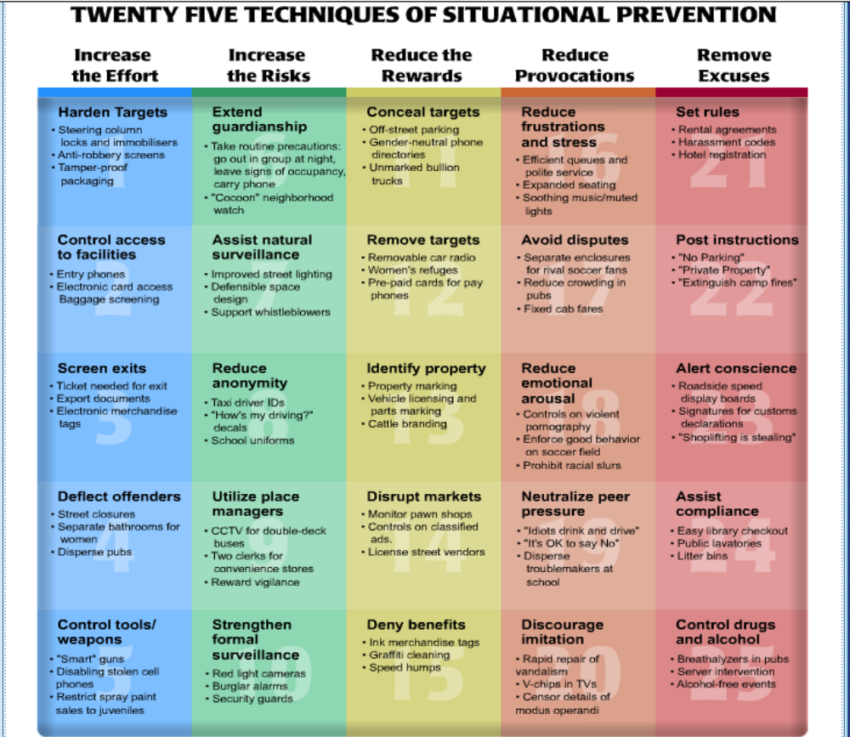

1. Target hardening. An obvious, often highly effective way of reducing criminal
opportunities is to obstruct the vandal or the thief by physical barriers through the use of
locks, safes, screens or reinforced materials.
2. Access control Access control refers to measures intended to exclude potential offenders from places such as offices, factories and apartment blocks. The portcullises, moats and drawbridges of medieval castles suggest its preventive pedigree may be aslengthy as that of target hardening. It is also a central component of defensible space, arguably the start of scientific interest in situational prevention. A sophisticated form of access control lies in the use of electronic personal identification numbers (PINs) that are needed to gain access to computer systems and bank accounts.
3. Deflecting offenders. At soccer matches in Britain, rival groups of fans have been segregated in the stadium to reduce fighting and their arrival and departure has been scheduled to avoid the periods of waiting around that promote trouble (Clarke, 1983). Scheduling the last bus to leave immediately after pub closing time, is intended to interfere with another of Britain's less admirable traditions, the closing time brawl. Hope (1985) has suggested that crowds of drunken young people on the streets at closing time could also be reduced by avoiding the concentration of licensed premises in particular parts of the city. Bell and Burke (1989) show that the leasing of a downtown parking lot in Arlington, Texas, relieved severe congestion on weekend nights in nearby streets, and associated crimeproblems, by providing a venue for teenage cruising. These are all examples of "deflecting offenders" away from crime targets, a situational technique suggested by routine activity theory.

4. Controlling facilitators. Saloons in the Wild West routinely required customers to surrender their weapons on entry because of the risk of drunken gun fights.The Scottish Council on Crime (1975) suggested that in some pubs beer should be served in plastic mugs to prevent their use as weapons, and recent studies in Britain of the injury potential of different kinds of broken glass have led to the recommendation that toughened glass be used for beer glasses.The introduction of identification procedures in Sweden produced a dramatic decline in the number of reported check frauds.

5. Entry/exit screening. Entry screening differs from access control in that the purpose is less to exclude potential offenders than to increase the likelihood of detecting those not in conformity with entry requirements. These requirements may relate to prohibited goods and objects or, alternatively, to possession of tickets and documents. Exit screens, on the other hand, serve primarily to deter theft by detecting objects that should not be removed from the protected area, such as items not paid for at a shop. Developments in electronics have resulted in the increasing use of these situational techniques in retailing, as evidenced by the spread of merchandise tagging, bar-coding and "electronic point of sales" systems
6. Formal surveillance. Formal surveillance is provided by police, security guards and store detectives, whose main function is to furnish a deterrent threat to potential offenders.
7. Surveillance by employees. In addition to their primary function, some employees, particularly those dealing with the public, also perform a surveillance role by virtue of theirposition.
8. Natural surveillance. Householders may trim bushes at the front of their homes and banks may light the interior of their premises at night in attempting to capitalize upon the "natural" surveillance provided by people going about their everyday business. Enhancing natural surveillance is a prime objective of improved street lighting (Tien et al., 1979; Ramsay, 1991a), of defensible space (Mayhew, 1979; Coleman, 1985), and of "neighborhood watch" (Bennett, 1990; Rosenbaum, 1988).
9. Target removal. A church in Northern Spain has recently installed a machine at its entrance that allows people to use their bank or credit cards to make donations.The person making the donation has a receipt for tax purposes and the church may receive larger gifts. Since money is not being deposited, the church has also reduced its theft risk through "target removal."
10. Identifying property. Writing one's name in a book is a simple form of property marking — a space is provided in this book for that purpose. The most developed programs of identifying property relate to vehicles. Registration of motor vehicles was required in some U.S. states from almost the beginning of the century and, subsequently, all vehicles sold in the United States were required to carry a unique Vehicle Identification Number
11. Reducing temptation. In certain city streets it is unwise to wear gold chains or leave cars parked which are attractive to joyriders.
12. Denying benefits. Related to reducing temptation, but conceptually distinct, is denying the benefits of crime to offenders. The recent development of security-coded car radios that require a thief to know the radio's PIN before it can be used in another vehicle constitutes an excellent example of this principle. Cars fitted with these radios have been found to have lower theft rates in studies in Australia (NRMA Insurance Ltd. 1990) and in Germany and the United States
13. Rule setting. All organizations find it necessary to have rules about conduct in their fields of governance. For example, most businesses regulate employees' telephone use and all retail establishments require their employees to follow strict cash handling and stock control procedures.
14. Stimulating conscience. This situational technique can be distinguished from society's more general informal social control by its focus on specific forms of crime occurring in discrete, highly limited settings (Clarke and Homel, 1997). Rather than attempting to bring about lasting changes in generalized attitudes to law breaking, these measures serve simply to stimulate feelings of conscience at the point of contemplating the commission of a specific kind of offense. For example, signs at store entrances announce that "shoplifting is stealing" and in the Port Authority Bus Terminal in Manhattan they proclaim that "Smoking here is illegal, selfish and rude."

15. Controlling disinhibitors. Crime is not only facilitated by tools such as weapons, but also by psychological disinhibitors, which include:
(i) alcohol and drugs, whichundermine the usual social or moral inhibitions, or impair perception and cognition so that offenders are less aware of breaking the law
ii) propaganda, which can be directed at the dehumanization of target groups (such as Jews — see Bauer,
1990) and can provide the moral certainties and justifications that ordinary people need to commit atrocities and war crimes.
16. Facilitating compliance. When Lombroso suggested in the 19th century that people should be locked up for publicly urinating in the streets, his pupil Ferri suggested an alternative more in keeping with the spirit of this book — the provision of public urinals

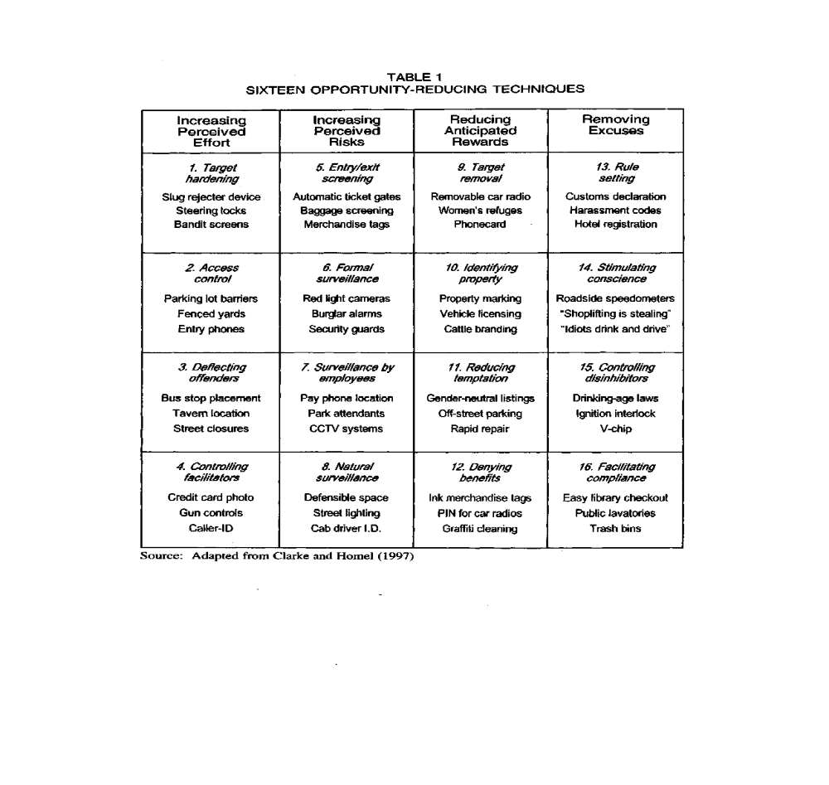

Broken Windows Theory
- Minor incivilities, if unchecked and uncontrolled, will promote more serious crimes
- ‘Incivilities’ act as the catalyst: they represent signs of disorder and signify that 'no one cares', that the environment is ‘uncontrolled and uncontrollable’
- Solution: stop and reverse the cycle of decline in its earliest stages by a focus on ‘order maintenance’ and aggressive policing of incivilities and other signs of crime.
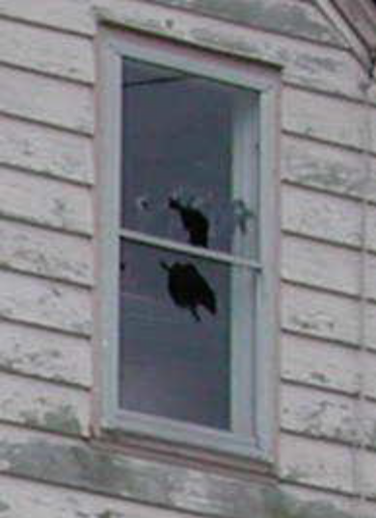

Importance of the 25 Techniques
- Help to systematize our knowledge
- Provides a stimulus for research
- The techniques may overlap - Increasing efforts can also increase risks
- Some preventive measures can serve more than one purpose
- Best used to help further thinking at the Response phase of the SARA process
Limitations
Not all techniques are equally suitable for all types of crimes. For example:
- Removing excuses may be most effective for dealing with “everyday” crimes
- Reducing provocations may be most effective in closed environments

4. A BODY OF EVALUATED PRACTICE INCLUDING STUDIES OF DISPLACEMENT.

